Introduction
The action of different research centers, ecologic non-government organizations and interested parties has installed with force the issue of the threats posed by an unrestricted biofuels expansion worldwide. Faced with the awareness of these matters, the political sector reacted by requesting measures from their regulation bodies, to put this activity in order. Such bodies have turned to institutes and research groups in look for adequate tools to provide scientific criteria and foundations for the regulations under preparation.
Presently, the fact is that the speeds are asymmetric and there still remain many doubts and unsolved problems within the scientific field, which imply moving forward with considerable degrees of uncertainty. This reality is present in all contexts and, in spite of the uninterrupted regulation progress, certain measures are being taken in order to correct possible errors if confronted with lack of sound and consolidated support.

Since the year 2005, the INTA (National Institute of Agriculture Technology) has been taking part in different technologic and scientific forums devoted to the study of the sustainable production of bioenergy worldwide.

Alliances with the major research centers in the field have been created and strengthened, and collaborative work has been carried out with the exchange of information and knowledge -new in many cases- about Argentina. These actions have been carried out by actively participating in international forums: the Global Bioenergy Partnership (GBEP) and the Roundtable on Sustainable Biofuels (RSB), as well as specific research projects such as the Global Biopact.
The National Bioenergy Program (NBP/PNB) of the INTA contemplates this issue as one of its main creation pillars, and it is within this frame that there is a specific project under way, related to energy balance, greenhouse gases, biodiversity, as well as the possible expansion area of different bioenergy crops and croplands.

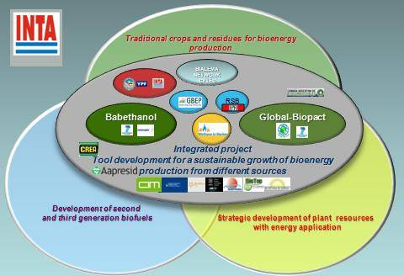
Figure 2 Portfolio of projects and alliances set by the INTA´s NBP/PNB

Analysis of the US approach of the issue
In recent years, different models have been incorporated to the general sustainability criteria adopted by European countries and the US. We shall now concentrate on the analysis of the methodology proposed by the United States Environmental Protection Agency (EPA-2009), since it summarizes in just one reference document the state of the art to attempt at arriving at the different biofuels quantification, qualification and classification.

As part of the “National Renewable Fuel Standard” (RFS), in accordance with the requirements of the “Energy Independence & Security Act” of 2007 (EISA) -it is the first American regulation which incorporates the concept of greenhouse gas limits and mitigation objectives for fuels replacing oil, and sets the classification parameters for each type of alternative fuel-, the EPA focuses on studying a methodology which enables the achievement of those values, based on the analysis of each product´s lifecycle, with an emphasis on greenhouse gas emissions.
Taking as bottom line greenhouse gas generation throughout the full fossil fuel lifecycle (GHGLCA), the following aims are set for the year 2005: a reduction by 20% for all gasoline-alternative biofuel, 50% for biodiesel and 60% for cellulosic-origin biofuel.
The EISA defines as GHGLCA the cumulative amount of GHG including significant direct and indirect emissions such as those originated in land use change (LUC) as instructed by the application authority concerning the complete cycle of the substituted fuel (well to tank). The mass values will be added according to their contribution to global warming.

The EPA has not found in the international bibliography a model which can be adopted for the calculation of the parameters requested by the EISA, thus making use of the most prestigious available tools for the calculation of each separate part. These tools are based on agricultural production econometric and evolution forecast models together with data bases (GREET, FASOM, FAPRI, NREL/USDA, MOVES/GREET).
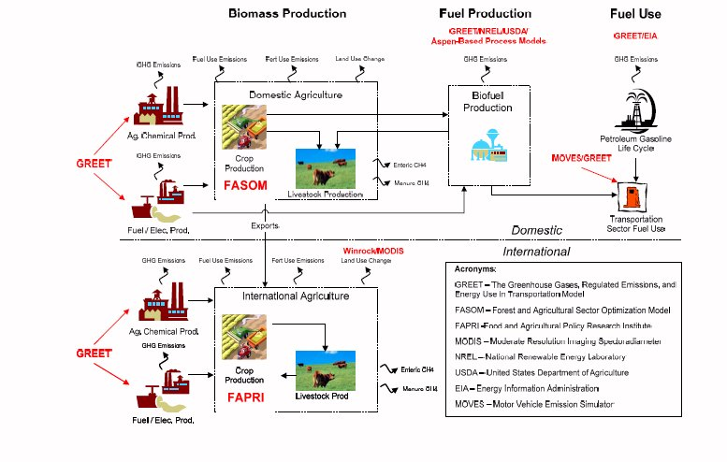

Figure 3 Set of models and information bases adopted by the EPA to establish the impact of each biofuel

In order to quantify the increase of GHG emissions generated throughout the lifecycle of biofuels, which may be expected from the application of the mandatory cut set by the EISA, the EPA research work compares the emissions in two possible scenarios:
- Emissions following the biofuel consumption trend prior to the existence of regulations (“Business as usual”).
- Increase to be generated through the application of the EISA mandatory cuts.

The EPA report contains a thorough analysis of the components of the total emissions per crop as the result of those produced at each stage of its lifecycle: production, industrialization and marketing, taking future emissions caused by land use change to the present value.
Figure 4 shows the range of direct and indirect emissions (induced by modification of land use) which vary for the different crops, and where the altered type of vegetable cover acquires fundamental importance, both inside and outside the US, due to the expansion of agriculture destined to bioenergy crops.

Figure 4 Fossil fuel emission levels compared with different biofuels, taking into account those coming from land change use (light green)

The EPA report suggests that, although land use change destined to raw materials for biofuels produces a GHG increase in the short term, it produces a reduction in the long term. Thus, it becomes necessary to estimate the present value of the biofuels future emissions in relation with those of the fuels they replace.

The variables with major incidence in the calculation of emission are:
- Time horizon considered
- Discount rate

Figure 5 presents the results obtained by calculating the emissions net present value (NPV) considering a 100-year time horizon and a 2% discount rate. Considering a 0% discount rate and a 30-year time horizon, the average reduction is smaller. The shorter the payback period, the more negatively biofuels are affected.
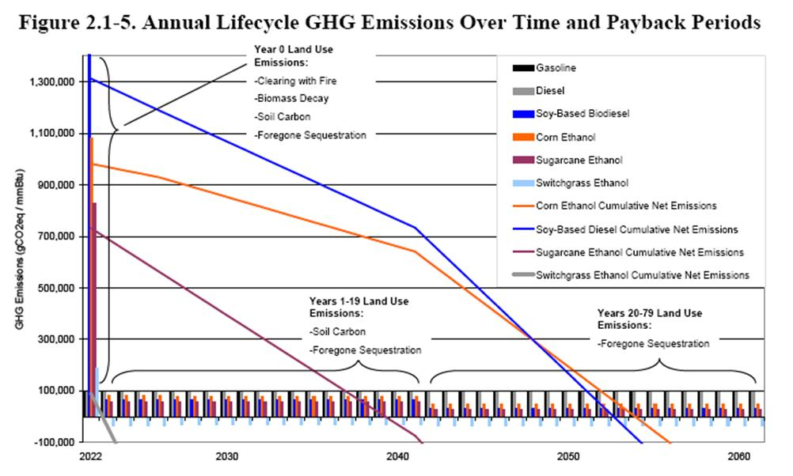
Figure 5 Graphic representation of the calculation methodology used in obtaining the present net value of the estimated future emissions of each biofuel, according to the forecasts of the models applied in each case.

Another variable determining relevant differences in GHG emissions is:
- The kind of cover altered by the expansion of croplands for biofuels.

Due to the the strong impact of the original kind of land cover involved in the calculation, the present analysis focused on this parameter.

Emissions produced by land use change
The larger consumption of biofuels in the US would imply a variation in land use within the territory, and may induce extraborder modification as well, whether to replace the crop area suffering a reduction in the US or in order to satisfy this country´s biofuels demand. The final effect of this advance will be the result of:
- Overall affected area
- Class of cover affected
- Associated gas emissions
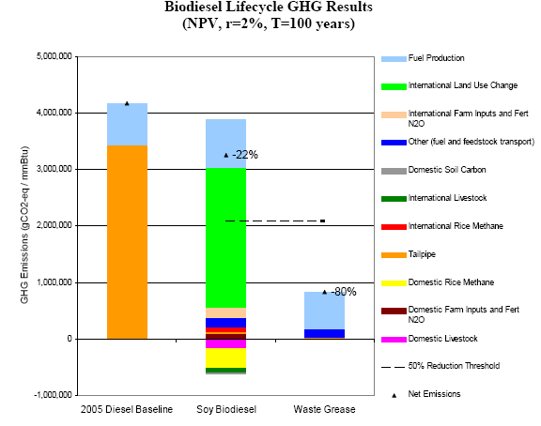
Figure 6 Comparative graph of diesel and soy biodiesel. In light green, the significant contribution of land use change.

The EPA acknowledges that the introduction of international land use change (ILUC) implies raising the uncertainty of the results obtained. The FAPRI math model was chosen for extraborder expansion, while the FASOM was used for the US.

Sources of land classification on an international level
The determination of land use patterns was made through MODIS satellite images with a 1-km resolution (pixel) for the years 2001 and 2004. The document explains the errors deriving from this classification, originally composed by 17 classes of land use, which were later on regrouped in five, leading to an increase in the margin of error.
There are significant differences in some land use classes between the different sources, such as that of FAO FRA 2005.
The figure presents the Argentine case taken by the EPA analysis, as regards the effect of grouping the original classes of land use.
Figure 7 MODIS original classes and simplified grouping performed by the EPA (2009)

Based on the analysis made on MODIS images, the table below displays the percentages assigned as sources for the expansion of croplands in Argentina for each different natural cover. In the case of Brazil, these determinations are performed per state.

Country | Forests | Grasslands | Savanna | Shrublands
Argentina | 8 | 40 | 45 | 8

Figure 8 Determination of land use variations arising from the EPA report, produced by the expansion of agriculture throughout the 2001-2004 period

The results for Argentina were obtained by applying the emission models on the Winrock/MODIS basis of different land uses. The emission factors do not distinguish the kind of agricultural system applied -such as that of direct sowing, of high significance in the case of Argentina.
In order to determine the impact of land use change estimated for each country, the Winrock model was used following the IPCC Agricultural Forest / Other Land Use (AFOLU) guide. Emissions are based on the initial carbon stocks at surface and subsurface levels, and in the case of Argentina, the reference taken was the forest carbon stock calculated by Gibbs et al (2007).
The emissions of the different land classes due to probable use changes were estimated on the basis of global maps, using a reclassification of the FAO-UNESCO lands map combined with a climatic/land map.
These models assume that agricultural activities generate soil carbon losses over a period of 20 years. Based on the results, the EPA in a first instance calculates the payback time of natural covers replacement by crops or plantations for biofuels.
- Corn 33 years
- Soy 32 years
- Sugarcane 18 years
- Switchgrass 3 years
As the EISA asks for clear GHGLCA values, the EPA determines values for each biofuel on the basis of calculating a present net value (PNV) for each alternative. The organization acknowledges that there are two variables of significant impact in the final value obtained.
The EPA claims that the factor of emissions due to international land use change (ILUC) presents major uncertainties, and thus calls for international assistance in order to improve on this approximation. Given the fact that these figures may vary significantly, it is clearly stated that the values are not final, leaving room for a revision and possible correction through a methodology to be determined.
The EPA considered the alternative of using other diagnostic methods for the analysis of land use change, such as the Global Trade Analysis (GTAP 2000-2001) model, which estimates changes based on economic relations, but did not judge it as robust as the FAPRI. All the same, it gives allowance for the possibility of potentially using information produced by the different countries, in connection with variations detected in land use.
The present work points at making a contribution in this sense.

Detail of emission factors per country
The document contains the results obtained in connection with land conversion destined to bioenergy crops or plantations, starting from other grasslands or covers of larger carbon sequestration, in relation with the original use of the lands where such expansion would take place. The compensated factor of emissions in MTCO2-eq per acre is of 60 for Argentina (25 related to cropland expansion and 34% to grassland replacement).

Sensitivity analysis
The discount rate factor in the final PNV calculation of future emissions has a significant impact on the final outcomes obtained in those biofuels containing a strong component derived from indirect land use change, as is the case of soy biodiesel. The time period considered is another factor of high gravitation in these cases.
A second sensitivity analysis was performed taking into account the different classes of land use which could be employed for the expansion of bioenergy-destined crops. The use of forests or improductive abandoned areas produces significant variations in the final outcomes. According to the results obtained in this study, this argument could be presented by Argentina with views of correctly determining what type of land cover could be experiencing variation through the expansion of crops and croplands for bioenergy. For the case of soy biodiesel, the occupation of forests increases GHG emissions by 15%, whereas a 65% reduction would be verified if agriculture should extend on grasslands (considering a 100-year payback time at a 2% discount rate).
These results clearly show the weight in overall emissions of the contribution deriving from land use change produced by the expansion of croplands, compared with those deriving from the industrial or agricultural production stages.

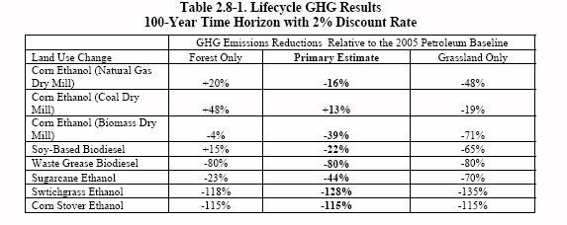
Figure 9 Emissions reduction related with the previous type of land use (100 years with a 2% discount rate)

It thus proves of vital importante to determine with absolute certainty the variations in land use taking place in Argentina in recent years, and to verify the degree of precision of the determinations appearing in the EPA report, based on the interpretation of the MODIS satellite images for the years 2001 and 2004, and used as a basis in modelling the trend of future changes.

Study carried out by the INTA
The methodology described in the report was perfectly reproduced so as to verify the magnitud of the changes and identify their origin. The MODIS satellite product (Modis/Terra land cover type yearly L3 Global 1 km SIN Grid V004 2001 and 2004) was downloaded and used to generate the information contained in the report of the web page
https://wist.echo.nasa.gov/wist-bin/api/ims.cgi?mode=MAINSRCH&JS=1
and for each year, the different categories of land cover were assigned as they appear in the original IGBP Land Cover Class assignment (EPA report, Table 2 623).

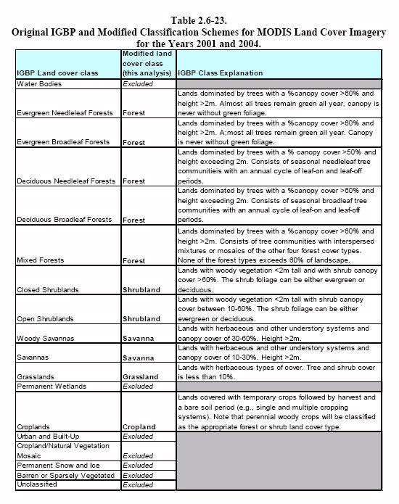

Figure 10 Reduction of MODIS classes proposed in the study carried out by the EPA

The original classification in 18 categories was reduced to 6 (as may be verified in Figure 10), highlighting those of major importance from the point of view of GHG capture: Forest, Savanna, Shrub and Grassland, and the area devoted to Cropland. The remaining categories were reassigned as Mixed, and are those excluded from the EPA report analysis. The categories with a different cover for Argentina for the years 2001 and 2004 may be seen in Figure 7.

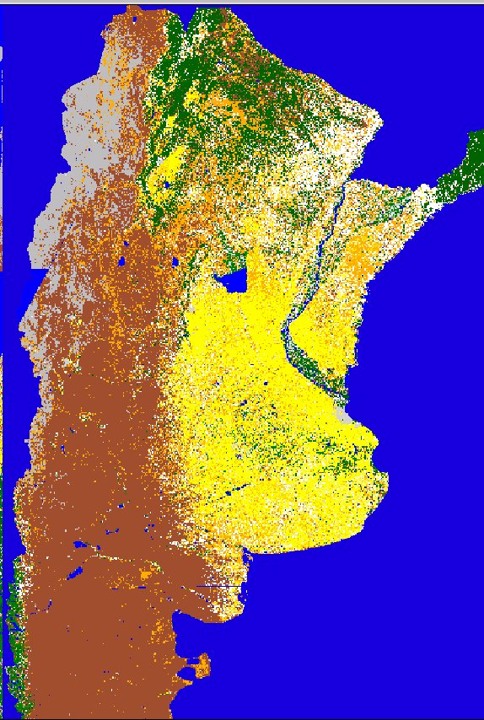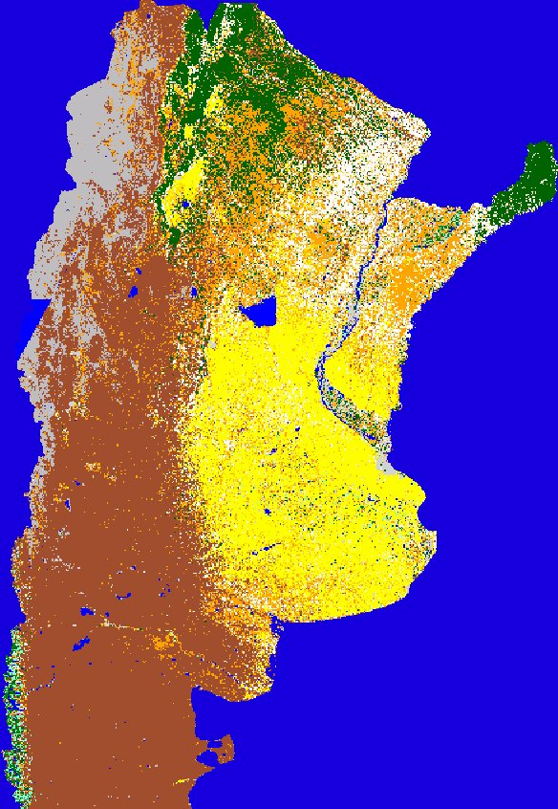

Figure 11a: MODIS classification 2001 Figure 11b: MODIS classification 2004
The 6 categories obtained through reassignment correspond to Croplands (yellow). Forests (green), Savanna (beige), Grasslands (orange), Shrublands (brown) and Mixed (grey)

The area identified with each type of land use, both in 2001 and 2004, according with the classification performed with the MODIS product, was computed through the addition of pixels (smallest information unit arising from the 1km by 1km classification) assigned to each category, and included in a double entry table, showing the area which remained steady through the two years in the category coincidence box; and in the rest, the changes verified between categories Figure 12
Owing to the importante given to the type of use modified by the incorporation of lands to agriculture, the area of those uses which according to the EPA report present a high conservation value due to their GHG sequestration (Forest, Savanna, Shrubland and Natural Grassland) were added and derived to Agriculture throughout Argentina during the research period, reaching an overall area of 9,654,462 has. The percentages of change for Argentina were obtained by relating the total area incorporated to agriculture with the area modified in each type of environment, being similar to those arising from the EPA report.

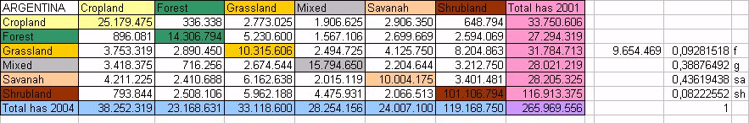
Figure 12 Areas computed for the different categories in Argentina in 2001 and 2004

Country | Forests | Grasslands | Savannas | Shrublands
Argentina (EPA) | 8 | 40 | 45 | 8
Argentina (INTA) | 9 | 39 | 44 | 8
Figure 13 Percentages of origin of land use transformations toward agriculture on a national level

To culminate this analysis on a national level, a similar study was carried out on a provincial level, proving that the province of Buenos Aires accounted for 50% of the changes: 4,684,681 has of expansion toward agriculture from other covers in the 2001-2004 period (Figure 14), non-matched whatsoever with official statistics from both national and provincial bodies for the period considered.

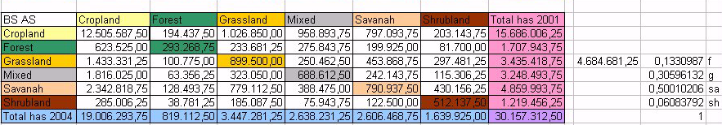

Figure 14 – Areas computed for the different categories in Buenos Aires in 2001 and 2004
Country | Forests | Greenlands | Savanna | Shrub
Buenos Aires (INTA) | 13 | 30.5 | 50 | 6

Figure 15 Percentages of origin of the transformations of land use toward agriculture on a national level

To verify the certainty of the changes assigned to Argentina, an extraction of the pixels of change detected by the classification of the MODIS products for the two years considered was made with ERDAS IMAGINE 8.4 modeling tools (Figure 16), and the pixels corresponding to the categories modified through their incorporation to agriculture were selected.
In Figure 17, the pixels which, according to the work serving as reference for the EPA were changed from native forest to cropland appear in green; those deriving from savanna, in red; and those coming from shrub, in brown, all within the province of Buenos Aires.
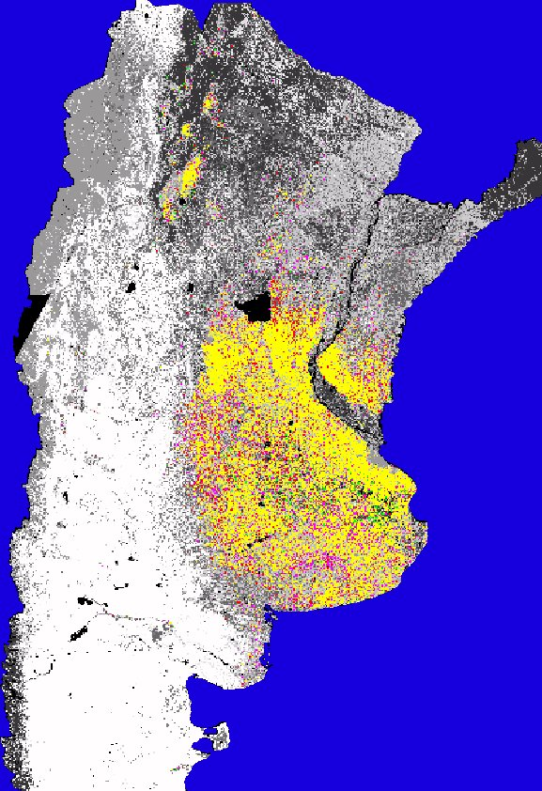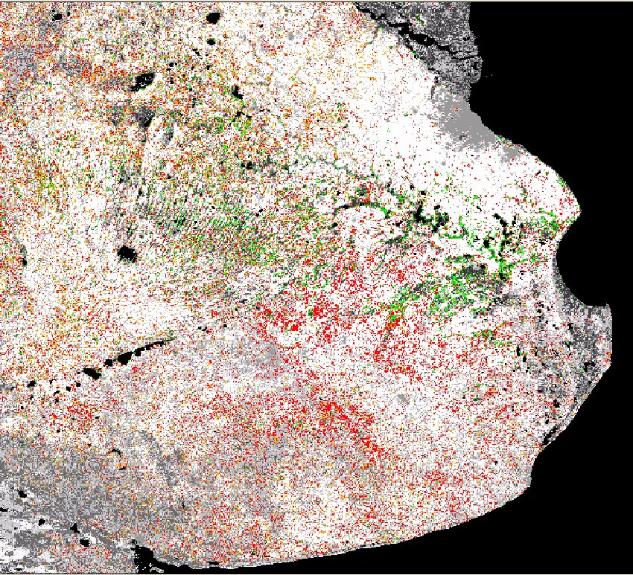
Figures 16 and 17 Area derived to agriculture from Native Forest (green), from Savanna (beige), from Shrub (brown) and from Grassland (red). The Croplands remaining in the same category (yellow) have been suppressed in Figure 4, for a clearer visualization of the changes.

To verify the certainty of the assignment of pixels detecting changes, these were put through LANSAT high resolution images of the years considered in the analysis (2001 and 2004). It was found on the images of 2001 that most of these pixels coincided with areas affected by a regional flooding which, throughout the whole year, covered a total area of 4,600,000 has, affecting mostly livestock production areas (grasses upgraded through years of environment intervention), but also areas which have been destined to agriculture for years. These traditional uses were recovered after the water drained (2004) and account for the wrong assignments. It must be highlighted that the category with major influence from the point of view of emissions - Evergreen Forests- does not exist in the areas classified within the analyzed province, and this
obeys to a common error in low resolution satellite classification, where the spectral response of forest areas is similar to that of the vegetation associated with wetlands in periods of hydric excess (such the situation in 2001).
To rule out the wrongly assigned pixels, they were substracted in the classification of the affected area with LANDSAT 2001 images, which resulted in a real area with land use change within the province of Buenos Aires of only 800,000 has.

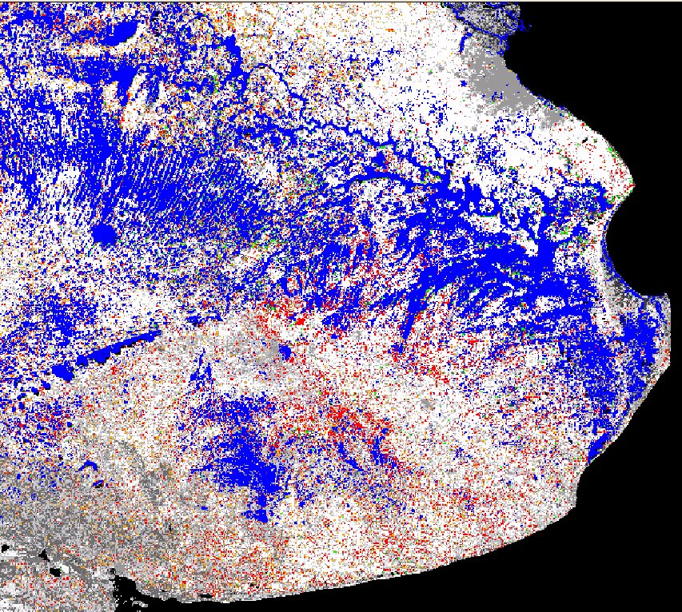

Figure 18 Area affected by flooding (blue) – Area associated to land use change (brown and reddish – total 800,000 has).

The variation pixels were overlapped on the province lands map (elaborated by the INTA on a 1:500.000 scale – Figure 6), verifying (Figure 7) that the changes toward agriculture, of the order of 800,000 has, took place in environments with lands of capabilities I to III. This is explained by the conversion to agriculture, in the last years, of areas devoted to intensive livestock production (milking plants or cattle fattening). Such type of exploitation was characterized by having grasslands implanted with land intervention (plowing and sowing) with a variable useful life according to the type of land and its management.
This advance in agriculture took place in the province with no reduction of cattle stock, but rather an intensification and higher efficiency in managing the rodeos, health control, etc. This phenomenon, actually verifiable in this region, contradicts one of the assumptions used by the models employed for iLUC calculation, which claim that agricultural expansion produces, as a consequence, a migration of livestock production toward marginal areas, with the resulting degradation or elimination of high biodiversity areas, such as forests.

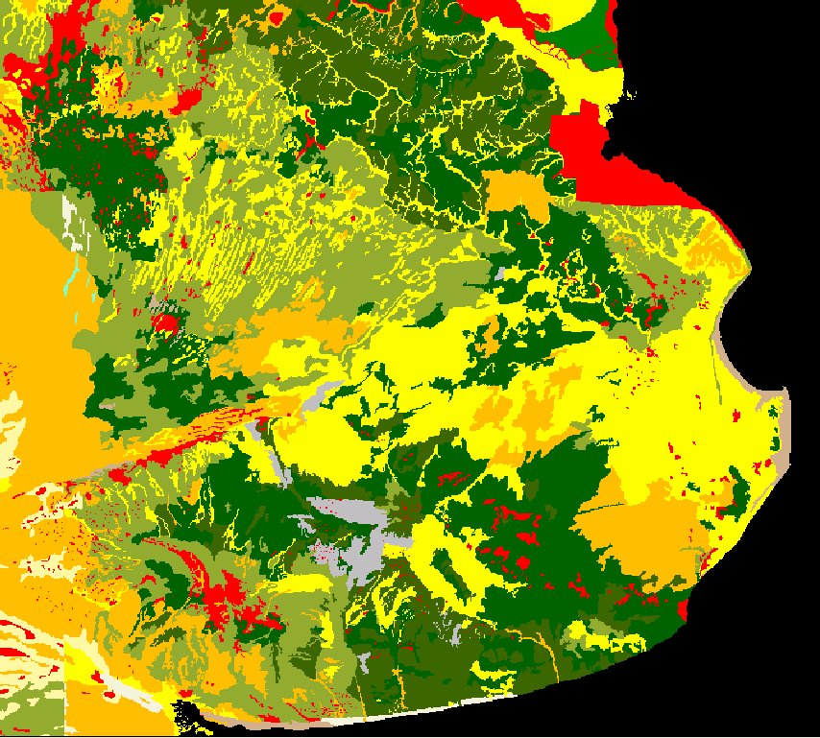

Figure 19 1:500 000 land map, where the lands with agriculture aptitude I and II have been colored in dark green; those of class III (with agriculture risk), in orange. In yellow, livestock fit areas; and in red, of no agricultural aptitude.
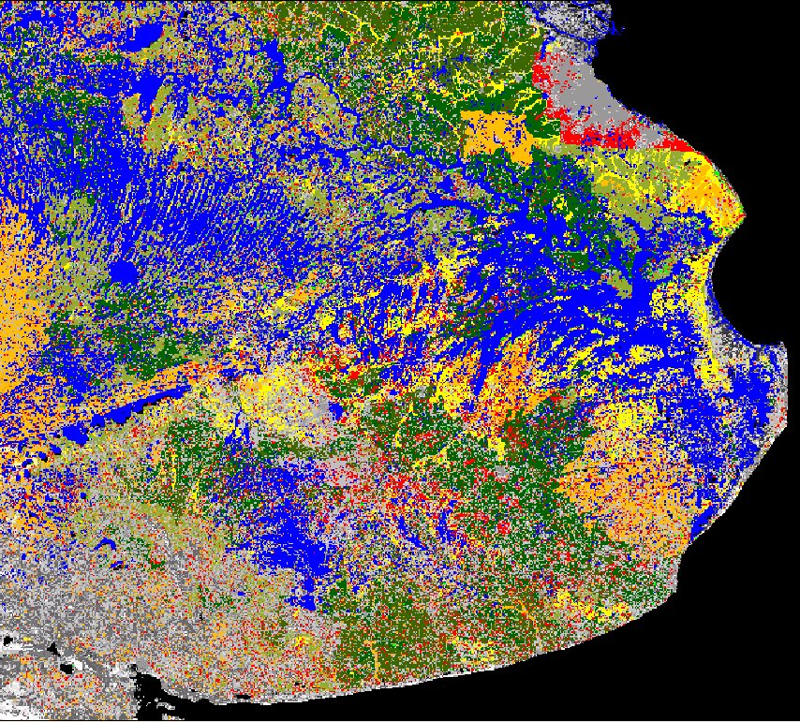

Figure 20 Flooded areas (blue) and change pixels (red)

Conclusions
- The influence of the original use of the lands converted to agriculture is highlighted in the estimations of greenhouse gas emisions.
- Significant errors have been verified in the determination of the original use of lands in the Argentine Republic, as well as the magnitude of the detected changes.
- It has been verified that errors may be made in using low resolution images without the adequate support of local experts.
- The real land origin as well as the magnitude of the changes would render significantly lower values for the case of Argentine soy.
- Agriculture expansion has been seen as not producing any significant reduction either in cattle stock or in its production, taking as witness case the province of Buenos Aires, and putting the assumptions of the models employed to the question.
- The errors arising from the assignment made by the EPA on the basis of a classification of low resolution images, without the assistance of local experts, are highly risky for the assignment of land use changes.
- Through the experience in cover classification, we can state that the 1-km resolution employed generates errors of a magnitude which can only be considered valid in analysis of academic type for the comprehension of the dynamic of change in the different vegetation covers detecting highly degrading actions, or to see the evolution of processes of large dynamism and impact in the environment, such as flooding, draught, etc, but may in no way be the basis of a research work to determine the magnitude of GHG emission changes, lest to determine a future trend which could be applied as an international trade regulatory instrument.
- To the considerations made above, the significant state intervention in agricultural markets should be added, as this may alter significantly the assumptions taken by the models, since they fail to consider these assumptions.

