FINANCIAL ASSISTANCE
FUNDING OPPORTUNITY ANNOUNCEMENT



U.S. Department of Energy
Golden Field Office

Integrated Process Improvements for Biochemical Conversion of Biomass Sugars: From Pretreatment to Substitutes for Petroleum-based Feedstocks, Products and Fuels

Funding Opportunity Announcement Number: DE-FOA-0000337 Announcement Type: Initial
CFDA Number: 81.087

Issue Date: 12/13/2010
Letter of Intent Due Date: 01/17/2011
Application Due Date: 02/07/2011, 11:59 PM Eastern Time

REGISTRATION AND APPLICATION SUBMISSION REQUIREMENTS

Registration Requirements: Allow at least 21 days to complete registrations.
To submit an application under this announcement, complete the following registrations:

- Obtain a Dun and Bradstreet Data Universal Numbering System (DUNS) number, at http://fedgov.dnb.com/webform.

- Register in the Central Contractor Registration (CCR) system, at https://www.ccr.gov/.
Designating an E-Business Point of Contact (EBiz POC) and obtaining a special password called an MPIN are important steps in CCR registration. These items are needed to submit applications in Grants.gov. Update your CCR registration annually.

- Register in Grants.gov at http://www.grants.gov/. See the Organization Registration User Guide at http://www.grants.gov/assets/OrgRegUserGuide.pdf.
The Applicant User Guide is at http://www.grants.gov/assets/ApplicantUserGuide.pdf.

- Register in FedConnect at https://www.fedconnect.net/; use “Register” link. To create an organization account, your organization’s CCR MPIN is required.

Where to Download the Application Package:
Download the Application Package for this announcement at http://www.grants.gov/. Click on the “Apply for Grants” link; then, click on the “Download a Grant Application Package” link and follow the instructions. Insert the announcement number to download the Application Package.

Where to Submit the Application Package:
Applications must be submitted through Grants.gov to be considered for award. Follow instructions in the User’s Guide for application submissions. Applicants are responsible for verifying successful transmission, prior to the Application due date and time.

Where to Ask Questions About the Funding Opportunity Announcement Content:
To ask questions about the Funding Opportunity Announcement, use FedConnect at https://www.fedconnect.net/. You must be a registered user in the system and submit questions by sending messages in your FedConnect email box. Part VII of this announcement explains how to submit questions to the Department of Energy (DOE).

Where to Submit Questions About the Registrations or Systems:

DUNS & Bradstreet: govt@dnb.com

Central Contractor Registration (CCR) system: https://www.bpn.gov/ccr/contactccr.aspx
By phone: 866-606-8220 or 334-206-7828 (8:00 a.m. to 8:00 p.m., Eastern Standard Time)

Grants.gov: support@grants.gov
By phone: 1-800-518-4726 (24 hours/day except for Federal Holidays)

FedConnect: support@FedConnect.net
By phone: 1-800-899-6665 (8:00 a.m. to 8:00 p.m., Eastern Standard Time except for Federal Holidays)
Table of Contents
Number Subject Page
SECTION I – FUNDING OPPORTUNITY DESCRIPTION 5
SECTION II – AWARD INFORMATION 7
A. Type of Award Instrument 7
B. Estimated Funding 7
C. Maximum and Minimum Award Size 8
D. Expected Number of Awards 8
E. Anticipated Award Size 8
F. Period of Performance 9
G. Type of Application 9
SECTION III - ELIGIBILITY INFORMATION 9
A. Eligible Applicants 9
B. Cost Sharing 9
C. Other Eligibility Requirements 10
SECTION IV – APPLICATION AND SUBMISSION INFORMATION 11
A. Address to Request Application Forms 11
B. Letter of Intent and Pre-Application 11
C. Content and Form of Application 12
D. Submissions from Successful Applicants 19
E. Submission Dates and Times 19
F. Intergovernmental Review 19
G. Funding Restrictions 19
H. Submission and Registration Requirements 20
SECTION V - APPLICATION REVIEW INFORMATION 21
A. Criteria 21
B. Review and Selection Process 25
C. Anticipated Notice of Selection and Award Dates 26
SECTION VI - AWARD ADMINISTRATION INFORMATION 26
A. Award Notices 26
B. Administrative and National Policy Requirements 27
C. Reporting 28
SECTION VII - QUESTIONS/AGENCY CONTACTS 28
A. Questions 28
SECTION VIII - OTHER INFORMATION 29
A. Modifications 29
B. Government Right to Reject or Negotiate 29
C. Commitment of Public Funds 29
D. Proprietary Application Information 29
E. Evaluation and Administration by Non-Federal Personnel 30
F. Intellectual Property Developed under this Program 30
G. Notice of Right to Request Patent Waiver 30
H. Notice Regarding Eligible/Ineligible Activities 31
I. Notice of Right to Conduct a Review of Financial Capability 31
J. Notice of Potential Disclosure under Freedom of Information Act 31
Appendix A – Definitions 32
Appendix B – Personally Identifiable Information 36
Appendix C – Cost Share Information 38
Appendix D – Budget Justification 44
Appendix E – Additional Detail on Definitions, Topic Areas and Explanations of Criterion 49
Appendix F – Data Tables 56
Appendix G – Stage-Gate Review Guidelines 65
Appendix H – Applicant’s Representation of Its Right to Commercialize Materials and Methods 72
Appendix I – Project Narrative Cover Sheet Template 73

SECTION I – FUNDING OPPORTUNITY DESCRIPTION

DESCRIPTION

The U.S. Department of Energy (DOE), Office of Energy Efficiency and Renewable Energy (EERE) announces a notice of availability of funds for financial assistance addressing the development, improvement and demonstration of integrated bench and/or engineering-scale process technology for the production of substitutes for petroleum-based feedstocks, products and fuels, which will improve the economics and efficiency of a biochemical or hybrid conversion process.

Government investment has been critical in enabling the development of technologies for the production of advanced biofuels, specifically cellulosic ethanol. Funding Opportunity Announcements (FOA) conducted by the Office of Biomass Program (OBP) since 2007 have funded research on biochemical conversion processes; in particular, they have supported the development of improved cellulases and fermentative organisms for ethanol production from cellulosic feedstocks. This FOA seeks diversification of the OBP portfolio to include a suite of fuels and chemicals (beyond ethanol) and ensure that research and development is being performed in an integrated fashion.

OBP’s emphasis on advanced biofuels is intended to encourage industry to invest in traditionally high-risk biofuels. Expanding the suite of cost competitive biofuels is necessary to meet the Energy Independence and Security Act of 2007 (EISA) Renewable Fuel Standards 2 (RFS2), and to ensure that all transportation sectors may take advantage of the benefits of renewable and sustainable advanced biofuels.

A total of approximately $30,000,000 is anticipated to be available for new awards under this announcement, subject to the availability of appropriated funds, in fiscal years 2011-2014.

Specifically, this FOA is requesting applications related to the following three separate topic areas:

- Topic Area 1: Process improvements to a single unit operation to be incorporated into an integrated system.

- Topic Area 2: Process improvements to 2 or more unit operations in an integrated system.

- Topic Area 3: Process improvements to 1 or more unit operations in an integrated system utilizing heterotrophic algal conversion organisms and technologies.

Appendix E provides further information regarding the individual topic areas.

All domestic entities are eligible to apply for this FOA, except nonprofit organizations described in section 501(c)(4) of the Internal Revenue Code of 1986 that engaged in lobbying activities after December 31, 1995. Domestic entities may include but are not limited to domestic institutions of higher education; Federally Funded Research and Development Centers; non-profit entities; for-profit entities; and State, local and tribal governments.

Feedstock
This FOA is focused on agricultural residues. However, other feedstock sources can be proposed in applications to this FOA if the applicant can show compelling evidence that the feedstock will be sustainably available by 2015. Appendix E provides further guidelines regarding this matter and, to be clear, only those feedstocks consistent with the Energy Policy Act (EPAct) of 2005 Section 932 (a) (1) & (2) are acceptable; however, aquatic species such as algae, seaweed, water hyacinths, etc., are NOT acceptable feedstocks under this FOA. Appendix E contains the EPAct 2005 Section 932 language that is applicable here. The proposed project must use biomass feedstocks. Applications that propose the use of pure sugar feeds and ‘model’ hydrolysates will be considered non-responsive and will NOT be considered for funding under this FOA
Process Operations
The chemical and biological processing of lignocellulosic feedstocks involves the integration of feedstock handling and processing with pretreatment and hydrolysis (saccharification) technologies and biomass sugar conversion technologies leading to production of alcohols and other biofuels, and separation and purification of the biofuel product. It is intended that the process operations to be included within this FOA are limited to pretreatment, hydrolysis, and conversion technologies leading to production of alcohols and other petroleum displacement products. Applications that propose R&D which involves a combination of hybrid chemical and biological conversion processes are acceptable as long as these hybrid systems confer advantages in meeting the goal of improving biomass sugar conversion to biofuels. Chemical conversion processes will be limited to catalytic conversion and will not include thermochemical processes for the purposes of this FOA. Applications that include thermochemical processes will be considered non-responsive and will NOT be considered for funding under this FOA. For example, fermentation of syngas from a gasification process will NOT be considered. Processes prior to pretreatment and saccharification or after conversion to final product will NOT be considered. If a catalytic conversion process is proposed, the hydrogenation process may NOT be included in the proposed process improvements to be funded under this FOA. While the entire process must be considered in the economics of biofuel production, this FOA will only focus on select aspects of this overall process. Hence, process improvements in pretreatment, hydrolysis, and/or conversion technologies are the only areas that will be eligible and allowable for cost-shared support as a part of the project funds. Project funds for R&D in these areas specifically includes applicant cost share.
Other Considerations
Under this FOA DOE will fund improvement and integration of existing process systems. DOE will NOT fund biocatalyst (enzyme or microorganism) discovery under this FOA. Funds are not intended for basic research leading to process development, although if an applicant deems such R&D to be necessary to achieve performance targets, the inclusion of such work may be included in the overall project plan and schedule, up to 20% of the total proposed budget under Topic Area 1 and 2. Under Topic Area 3, up to 50% of the total proposed budget may be used for basic research leading to process development. Additionally, DOE will NOT fund improvement of processes for the production of ethanol, biogas and biodiesel produced from transesterification or hydrotreating or hydrocracking of agronomic, natural plant oils (e.g., soybeans, palm, coconut, safflower, castor, etc.) under this FOA. Applications proposing improvements to the previously listed technological processes (i.e. biocatalyst (enzyme or microorganism) discovery, improvement of processes for the production of ethanol, biogas and biodiesel produced from transesterification or hydrotreating or hydrocracking of agronomic, natural plant oils) will be considered non-responsive and will NOT be considered for funding under this FOA.
After selection and award, the recipient must accept: a) an independent validation of the baseline technical and economic data, which must be provided in the application; b) a Stage-Gate review of the project’s progress in meeting intermediate/Stage-Gate performance and economic targets (see Appendix G); and c) a final validation of the project’s progress in meeting the final performance and economic targets.
The validations will be conducted by the National Renewable Energy Laboratory (NREL). DOE will conduct the Stage-Gate review using independent consultants and will employ the results of the validations. NREL has in place nondisclosure obligations and formal conflict of interest agreements with DOE to segregate individuals doing the validations from other individuals at the laboratory who may be involved in applicant teams. The identified individuals will not be allowed to participate with any potential applicant, nor will NREL be allowed to apply directly to this FOA. DOE also reserves the right to conduct a third validation at an appropriate time and, if necessary, to assess the performance of the process(es). If selected for award, applicants must execute any necessary nondisclosure agreements with third parties assisting DOE with the validation process so that validations may be conducted as expeditiously as possible.
Applicants are asked to read Appendix E for further information regarding the details of the topic areas and further guidelines concerning submitting their most viable application. Note that applications that fail to include the Technical and Economic Tables and the Representation of Right to Commercialize Materials and Methods (Appendices F & H), will be considered non-responsive and will NOT be considered for funding under this FOA.

SECTION II – AWARD INFORMATION

A. Type of Award Instrument

Grants and Cooperative Agreements
- DOE anticipates awarding both grants and cooperative agreements under this program announcement. If it is determined that a cooperative agreement is the appropriate award instrument, the nature of the Federal substantial involvement will be included in a special award condition.

B. Estimated Funding
Amount Multiple Year Awards
- Approximately $ 8,000,000 is expected to be available for new awards in FY 2011 and an additional $ 22,000,000 is expected to be available for awards made under this announcement in years FY 2012 through FY2014. The actual level of funding, if any, depends on appropriations for this program. All awards are subject to annual appropriations to DOE and the availability of funding.

C. Maximum and Minimum Award Size
- Ceiling (i.e., the maximum amount for an individual award made under this announcement):
Topic Area 1: $5,000,000
Topic Area 2: $15,000,000
Topic Area 3: $5,000,000
- Floor (i.e., the minimum amount for an individual award made under this announcement):
Topic Area 1: $2,000,000
Topic Area 2: $5,000,000
Topic Area 3: $2,000,000

D. Expected Number of Awards
Number of Awards per Program/Topic Area
- Under this announcement, DOE expects to make the following number of awards for each Program/Topic Area:

Program/Topic Area | Number of Awards
1 | 1-3
2 | 1-2
3 | 1-2

E. Anticipated Award Size

Award Size Per Program Area
- The anticipated award size for projects under each Program/Topic Area in this announcement is:

Program/Topic Area | Awards Size
1 | $5,000,000
2 | $10,000,000
3 | $5,000,000

F. Period of Performance

Award up to 36 Months
- DOE anticipates making awards that will run for up to 36 months over two budget periods. The first budget period will cover a period of up to 24 months with an option for a continuation of up to an additional 12 months, contingent upon satisfactory performance of the first budget period in meeting project milestones and technical targets and completion of the Stage Gate review process.

G. Type of Application

New Applications Only
- DOE will accept only new applications under this FOA (i.e., applications for renewals of existing DOE funded projects will not be considered).

SECTION III - ELIGIBILITY INFORMATION

A. Eligible Applicants

- All domestic entities are eligible to apply for this FOA, except nonprofit organizations described in section 501(c)(4) of the Internal Revenue Code of 1986 that engaged in lobbying activities after December 31, 1995. Further, the National Renewable Energy Laboratory (NREL) is not eligible to participate as a lead applicant due to their unique role relative to the projects to be funded under this announcement, though NREL may participate as a sub recipient, up to 50% of the total project.
- Please be advised that DOE intends to issue awards to existing entities, and not to entities specifically established for the limited purpose of carrying out a project under this FOA.

B. Cost Sharing

Cost Share 20%
- The cost share must be at least 20% of the total allowable costs for research and development projects (i.e., the sum of the Government share, including FFRDC contractor costs if applicable, and the recipient share of allowable costs equals the total allowable cost of the project) and must come from non-Federal sources unless otherwise allowed by law. (See 10 CFR Part 600 for the applicable cost sharing requirements.)
- With the consent of the Contracting Officer, the Recipient may concentrate its cost share in earlier phases or budget periods of the project (front-load) so long as Recipient meets its overall cost share requirements. However, Recipient is prohibited from concentrating its cost share in later budget periods or phases (back-loading).

C. Other Eligibility Requirements

- DOE National Laboratory Contractors and Other Federally Funded Research and Development Center (FFRDC) Contractors.
A DOE National Laboratory Contractor, with the exception of NREL, is eligible to apply for funding under this announcement if its cognizant contracting officer provides written authorization and this authorization is submitted with the application. If a DOE National Laboratory Contractor is selected for award, the proposed work will be authorized under the DOE work authorization process and performed under the laboratory’s Management and Operating (M&O) contract. The following wording is acceptable for the authorization:
“Authorization is granted for the _____________ Laboratory to participate in the proposed project. The work proposed for the laboratory is consistent with or complementary to the missions of the laboratory, will not adversely impact execution of the DOE assigned programs at the laboratory, and will not place the laboratory in direct competition with the domestic private sector.”

FFRDC contractors may be proposed as team members on another entity’s application, subject to the following guidelines:
Authorization for non-DOE FFRDCs. The Federal agency sponsoring the FFRDC contractor must authorize in writing the use of the FFRDC contractor on the proposed project and this authorization must be submitted with the application. The use of a FFRDC contractor must be consistent with the contractor’s authority under its award. The following wording is acceptable for this authorization:
“Authorization is granted for the _____________ Laboratory to participate in the proposed project. The work proposed for the laboratory is consistent with or complementary to the missions of the laboratory, will not adversely impact execution of assigned programs at the laboratory, and will not place the laboratory in impermissible competition with the domestic private sector. This laboratory is authorized to perform the work proposed in the application submitted under DOE funding opportunity announcement # DE-FOA-0000337 by the following statutory authority ____________.”
Authorization for DOE FFRDCs. The cognizant contracting officer for the FFRDC must authorize in writing the use of a DOE FFRDC contractor on the proposed project and this authorization must be submitted with the application. The following wording is acceptable for this authorization:
“Authorization is granted for the _____________ Laboratory to participate in the proposed project. The work proposed for the laboratory is consistent with or complementary to the missions of the laboratory, will not adversely impact execution of the DOE assigned programs at the laboratory, and will not place the laboratory in direct competition with the domestic private sector.”

Value/Funding. The value of, and funding for, the FFRDC contractor portion of the work will not normally be included in the award to a successful applicant. Usually, DOE will fund a DOE FFRDC contractor through the DOE field work proposal system and other FFRDC contractors through an interagency agreement with the sponsoring agency.

Cost Share. The applicant’s cost share requirement will be based on the total cost of the project, including the applicant’s and the FFRDC contractor’s portions of the effort.

FFRDC Contractor Effort:
- The scope of work to be performed by the FFRDC contractor may not be more significant than the scope of work to be performed by the applicant.

Responsibility. The applicant, if successful, will be the responsible authority regarding the settlement and satisfaction of all contractual and administrative issues, including but not limited to, disputes and claims arising out of any agreement between the applicant and the FFRDC contractor.

SECTION IV – APPLICATION AND SUBMISSION INFORMATION

A. Address to Request Application Forms

Application forms and instructions are available at Grants.gov. To access these materials, go to http://www.grants.gov, select “Apply for Grants,” and then select “Download Application Package.” Enter the CFDA and/or the funding opportunity number located on the cover of this announcement and then follow the prompts to download the application package. (Also see Section H of this Part below.)

B. Letter of Intent and Pre-Application

- Letter of Intent
- Applicants are requested to submit a letter of intent by January 17, 2011. This letter should include the name of the applicant, the title of the project, the name of the Project Director/Principal Investigator(s), the amount of funds requested, and a one-page abstract. Additionally, the letter must include the topic area under which the application intends to apply. Letters of intent and accompanying abstracts will be used by DOE to organize and expedite the merit review process. They should not contain any proprietary or sensitive business information. Failure to submit such letters will not negatively affect a responsive application submitted in a timely fashion. The letter of intent should be sent by E-mail to FOA-0000337@go.doe.gov. DOE will not respond to the Letters of Intent.

- Pre-application
- A pre-application is not required.

C. Content and Form of Application

You must complete the mandatory forms and any applicable optional forms, in accordance with the instructions on the forms and the additional instructions below, as required by this FOA. Files that are attached to the forms must be in Adobe Portable Document Format (PDF) unless otherwise specified in this announcement.

Once the forms below have been completed, save the Application Package in a single file, using up to 10 letters of the Applicant’s Organization Name as the file name (e.g., Company). If your organization is submitting more than one Application, you must identify an application number at the end of each file name (e.g., Company-1). If your organization is submitting more than one Application to different topic areas, you must identify an application number and the Topic Area Number at the end of each file name (e.g., Company-1-Topic1).

1. SF 424 - Application for Federal Assistance
Complete this form first to populate data in other forms. Complete all required fields in accordance with the instructions on the form. The list of certifications and assurances referenced in Field 21 can be found at http://management.energy.gov/business_doe/business_forms.htm, under Certifications and Assurances.

2. Project/Performance Site Location(s)
Indicate the primary site where the work will be performed. If a portion of the project will
be performed at any other site(s), identify the site location(s) in the blocks provided. Note
that the Project/Performance Site Congressional District is entered in the format of the 2 digit state code followed by a dash and a 3 digit Congressional district code; for example, VA-001. In the form, hover over this field for additional instructions.

Use the “Next Site” button to expand the form to add additional Project/Performance Site Locations.

3. Other Attachments Form
Submit the following files with your application and attach them to the Other Attachments Form. Click on “Add Mandatory Other Attachment” to attach the Project Narrative. Click on “Add Optional Other Attachment,” to attach the other files.

- Project Summary/Abstract File
The project summary/abstract must contain a summary of the proposed activity suitable for dissemination to the public. It should be a self-contained document that identifies the name of the applicant, the project director/principal investigator(s), the project title, the objectives of the project, a description of the project, including methods to be employed, the potential impact of the project (i.e., benefits, outcomes), and major participants (for collaborative projects). This document must not include any proprietary or sensitive business information, as the Department may make it available to the public. The project summary must not exceed 1 page when printed using standard 8.5” by 11” paper with 1” margins (top, bottom, left and right), single spaced, with font not smaller than 11 point. Save this information in a file named “Summary.pdf,” and click on “Add Optional Other Attachment” to attach.

- Project Narrative File - Mandatory Other Attachment
The project narrative must not exceed 30 pages, including the Project Narrative Cover Sheet (see Appendix I), table of contents, charts, graphs, maps, photographs, and other pictorial presentations, when printed using standard 8.5” by 11” paper with 1 inch margins (top, bottom, left, and right), single spaced. EVALUATORS WILL REVIEW ONLY THE NUMBER OF PAGES SPECIFIED IN THE PRECEDING SENTENCE. The font must not be smaller than 11 point. Do not include any Internet addresses (URLs) that provide information necessary to review the application. See Section VIII.D for instructions on how to mark proprietary application information. Save the information in a single file named “Project.pdf,” and click on “Add Mandatory Other Attachment” to attach.

The project narrative must include:
- Project Objectives.
This section should provide a clear, concise statement of the specific objectives/aims of the proposed project, and the Topic Area under which the project is applying.
- Merit Review Criterion Discussion.
The section should be formatted to address each of the merit review criterion and sub-criterion listed in Part V. A. below. Provide sufficient information so that reviewers will be able to evaluate the application in accordance with these merit review criteria. DOE WILL EVALUATE AND CONSIDER ONLY THOSE APPLICATIONS THAT ADDRESS SEPARATELY EACH OF THE MERIT REVIEW CRITERION AND SUB-CRITERION.
- Relevance and Outcomes/Impacts:
This section should explain the relevance of the effort to the objectives in the program announcement and the expected outcomes and/or impacts. The justification for the proposed project should include a clear statement of the importance of the project in terms of the utility of the outcomes and the target community of beneficiaries.
- Roles of Participants:
For multi-organizational or multi-investigator projects, describe the roles and the work to be performed by each participant/investigator, business agreements between the applicant and participants, and how the various efforts will be integrated and managed.
- Facilities and Other Resources:
Identify the facilities (e.g., office, laboratory, computer, etc.) to be used at each performance site listed, and, if appropriate, indicate their capacities pertinent capabilities, relative proximity, and extent of availability to the project. Describe only those resources that are directly applicable to the proposed work. Provide any information describing the other resources available to the project, such as machine and electronics shops.

- Equipment:
List important items of equipment already available for this project, and if appropriate, note the location and pertinent capabilities of each. If you are proposing to acquire equipment, describe comparable equipment, if any, already at your organization and explain why it cannot be used.
- Bibliography and References, if applicable:
Provide a bibliography for any references cited in the Project Narrative section. This section must include only bibliographic citations.
All the components of your Project Narrative (listed above) must be within the Narrative page limit specified in paragraph b. above. Documents listed below may be included as clearly marked appendices to your Narrative and will not count towards the Project Narrative page limit. Please note that some of the required documents listed below may have their own page limits to which you must adhere.

- Resume File

Provide a resume for each key person proposed, including subawardees and consultants if they meet the definition of key person. A key person is any individual who contributes in a substantive, measurable way to the execution of the project. Save all resumes in a single file named “resume.pdf” and click on “Add Optional Other Attachment” to attach. The biographical information for each resume must not exceed 2 pages when printed on 8.5” by 11” paper with 1 inch margins (top, bottom, left, and right), single spaced, with font not smaller than 11 point and should include the following information, if applicable:

Education and Training. Undergraduate, graduate and postdoctoral training; provide institution, major/area, degree and year.

Professional Experience: Beginning with the current position list, in chronological order, professional/academic positions with a brief description.

Publications. Provide a list of up to 10 publications most closely related to the proposed project. For each publication, identify the names of all authors (in the same sequence in which they appear in the publication), the article title, book or journal title, volume number, page numbers, year of publication, and website address, if available electronically.

Patents, copyrights and software systems developed may be provided in addition to, or substituted for, publications.

Synergistic Activities. List no more than 5 professional and scholarly activities related to the effort proposed.

- Of the key personnel identified in this file, indicate the Principal Investigator(s) (PI).
- For Multiple Principal Investigators:
The applicant, whether a single organization or team/partnership/consortium, must indicate if the project will include multiple PIs. The decision to use multiple PIs for a project is the sole responsibility of the applicant. If multiple PIs will be designated, the application must identify the Contact PI/Project Coordinator and provide a “Coordination and Management Plan” that describes the organization structure of the project as it pertains to the designation of multiple PIs. This plan should, at a minimum, include:

    - Process for making decisions on scientific/technical direction;
    - Publications;
    - Intellectual property issues;
    - Communication plans;
    - Procedures for resolving conflicts; and
    - PIs’ roles and administrative, technical and scientific responsibilities for the project.

The resume file does not have a page limitation.

- Budget File

SF 424 A Excel, Budget Information – Non-Construction Programs File
You must provide a separate budget for each year of support requested and a cumulative budget for the total project period. Use the SF 424 A Excel, “Budget Information – Non Construction Programs” form on the DOE Financial Assistance Forms Page at http://management.energy.gov/business_doe/business_forms.htm.

You may request funds under any of the Object Class Categories as long as the item and amount are necessary to perform the proposed work, meet all the criteria for allowability under the applicable Federal cost principles, and are not prohibited by the funding restrictions in this announcement (see Section IV, G). Save the information in a single file named “SF424A.xls,” and click on “Add Optional Other Attachment” to attach.

- Budget Justification File
You must justify the costs proposed in each Object Class Category/Cost Classification category (e.g., identify key persons and personnel categories and the estimated costs for each person or category; provide a list of equipment and cost of each item; identify proposed subaward/consultant work and cost of each subaward/consultant; describe purpose of proposed travel, number of travelers and number of travel days; list general categories of supplies and amount for each category; and provide any other information you wish to support your budget). Provide the name of your cognizant/oversight agency, if you have one, and the name and phone number of the individual responsible for negotiating your indirect rates. In the budget justification, identify the following information for each third party contributing cost share: (1) the name of the organization; (2) the proposed dollar amount to be provided; (3) the amount as a percentage of the total project cost; and (4) the proposed type of cost share – cash, services, or property. By submitting your application, you are providing assurance that you have signed letters of commitment. Successful applicants will be required to submit these signed letters of commitment.

Save the budget justification information in a single file named “Budget.pdf,” and click on “Add Optional Other Attachment” to attach.

- Letters of Commitment
If cost share is required, you must have a letter from each third party contributing cost share (i.e., a party other than the organization submitting the application) stating that the third party is committed to providing a specific minimum dollar amount of cost share. All Letters of Commitment must be attached as an Appendix to the Project Narrative File. Identify the following information for each third party contributing cost share: (1) the name of the organization; (2) the proposed dollar amount to be provided; (3) the amount as a percentage of the total project cost; and (4) the proposed type of cost share – cash, services, or property. Letters of Commitment from parties participating in the project, exclusive of vendors, who will not be contributing cost share, but will be integral to the success of the project must be included as part of this Appendix to the Narrative. Letters of Commitment will not count towards the Project Narrative page limit.

- Subaward Budget File(s)
You must provide a separate budget (i.e., budget for each budget year and a cumulative budget) for each subawardee that is expected to perform work estimated to be more than $100,000 or 50 percent of the total work effort (whichever is less). Use the SF 424 A Excel for Non Construction Programs or the SF 424 C Excel for Construction Programs. These forms are found on the DOE Financial Assistance Forms Page at: http://management.energy.gov/business_doe/business_forms.htm. Save each Subaward budget in a separate file. Use up to 10 letters of the subawardee’s name (plus 424.xls) as the file name (e.g., company424.xls or energyres424.xls). Click on “Add Optional Other Attachment” to attach each file.

A budget justification for the subaward budget is also required. The budget justification must include the same justification information described in paragraph e. above.

- Budget for DOE Federally Funded Research and Development Center (FFRDC) Contractor File, if applicable
If a DOE FFRDC contractor is to perform a portion of the work, you must provide a DOE Field Work Proposal in accordance with the requirements in DOE Order 412.1 Work Authorization System. The DOE Order 412.1, Work Authorization System and the DOE O 412.1, Field Work Proposal form are available at the following link, under “DOE Budget Forms”:
http://management.energy.gov/business_doe/business_forms.htm
Use up to 10 letters of the FFRDC name (plus .pdf) as the file name (e.g., lanl.pdf or anl.pdf), and click on “Add Optional Other Attachment” to attach.

- Authorization for non-DOE or DOE FFRDCs
Save the Authorization for non-DOE or DOE FFRDCs, as specified in Section III.C. Other Eligibility Requirements, in a single file named “FFRDC_Auth.pdf” and click on “Add Optional Other Attachment” to attach.

- Project Management Plan
This plan should identify the activities/tasks to be performed, a time schedule for the accomplishment of the activities/tasks, the spending plan associated with the activities/tasks, and the expected dates for the release of outcomes. Applicants may use their own project management system to provide this information. This plan should identify any decision points and go/no-go decision criteria. Successful applicants must use this plan to report schedule and budget variances. Save this plan in a single file named “pmp.pdf” and click on “Add Optional Other Attachments” to attach.

- SF-LLL Disclosure of Lobbying Activities
If applicable, complete SF- LLL. Applicability: If any funds other than Federal appropriated funds have been paid or will be paid to any person for influencing or attempting to influence an officer or employee of any agency, a Member of Congress, an officer or employee of Congress, or an employee of a Member of Congress in connection with the grant/cooperative agreement, you must complete and submit Standard Form - LLL, "Disclosure Form to Report Lobbying.” The form is available in the optional document box on the Adobe Application Package attached to this FOA.

- Technical and Economical Data Tables
The tables provided in Appendix F of this FOA must be completed and included as an attachment to the application. Save these tables in a single Excel workbook named “Tables.xls” and click on “Add Optional Other Attachments” to attach.
- Representation of Right to Commercialize Materials and Methods
The form provided in Appendix H of this FOA must be completed and included as an attachment to the application. Save the form in a single file named “IP.pdf” and click on the “Add Optional Other Attachments” to attach.

Summary of Required Forms/Files
Your application must include the following documents:

Name of Document | Format | File Name
SF 424 - Application for Federal Assistance | Part of Adobe Application Package
Project/Performance Site Location(s) | Part of Adobe Application Package
Other Attachments Form: Attach the following files to this form: | Part of Adobe Application Package | See Instructions
Project Summary/Abstract File | PDF | Summary.pdf
Project Narrative File, including required appendices (Letters of Commitment) | PDF | Project.pdf
Resume File | PDF | Resume.pdf
SF 424A Excel – Budget Information for Non-Construction Programs File | Excel | SF424A.xls
Budget Justification File | PDF | See Instructions
Subaward Budget File(s), if applicable Budget Justification(s), if applicable | Excel for Budget  PDF for Justification | See Instructions
Budget for Federally Funded Research and Development Center (FFRDC) Contractor File, if applicable. | PDF | See instructions
Authorization from cognizant Contracting Officer for FFRDC, if applicable. | PDF | FFRDC_Auth.pdf
Project Management Plan | PDF | PMP.pdf
SF-LLL Disclosure of Lobbying Activities | PDF | SF-LLL.pdf
Technical and Economical Data Tables | Excel | Tables.xls
Representation of Right to Commercialize | PDF | IP.pdf

D. Submissions from Successful Applicants

If selected for award, DOE reserves the right to request additional or clarifying information for any reason deemed necessary, including, but not limited to:
- Indirect cost information
- Other budget information
- Commitment Letter from Third Parties Contributing to Cost Share, if applicable
- Environmental Questionnaire

E. Submission Dates and Times

1. Pre-applications are not required
2. Application Due Date
- Applications must be received by February 7, 2011 not later than 11:59 PM Eastern Standard Time. You are encouraged to transmit your application well before the deadline. APPLICATIONS RECEIVED AFTER THE DEADLINE WILL NOT BE REVIEWED OR CONSIDERED FOR AWARD.

F. Intergovernmental Review

This program is not subject to Executive Order 12372 – Intergovernmental Review of Federal Programs.

G. Funding Restrictions

Cost Principles. Costs must be allowable in accordance with the applicable Federal cost principles referenced in 10 CFR Part 600. The cost principles for commercial organization are in FAR Part 31.

Pre-award Costs. Recipients (except states or local governments) may charge to an award resulting from this announcement pre-award costs that were incurred within the ninety (90) calendar day period immediately preceding the effective date of the award, if the costs are allowable in accordance with the applicable Federal cost principles referenced in 10 CFR Part 600. Recipients must obtain the prior approval of the contracting officer for any pre-award costs that are for periods greater than this 90 day calendar period. If recipients are Tribal, State, or Local Governments, they may not incur pre-award costs prior to award, without prior approval of the DOE contracting officer.
Award recipients are restricted from taking any action using Federal funds, which would have an adverse effect on the environment or limit the choice of reasonable alternatives prior to DOE providing a National Environmental Policy Act (NEPA) clearance or final NEPA determination.

Pre-award costs are incurred at the applicant’s risk. DOE is under no obligation to reimburse such costs if for any reason the applicant does not receive an award or if the award is made for a lesser amount than the applicant requested.

H. Submission and Registration Requirements

- Where to Submit
APPLICATIONS MUST BE SUBMITTED THROUGH GRANTS.GOV, TO BE CONSIDERED FOR AWARD UNDER THIS ANNOUNCEMENT. You cannot submit an application through Grants.gov unless you are registered. Please read the registration requirements below carefully and start the process immediately. Submit electronic applications through the “Apply for Grants” function at www.Grants.gov.

If you have problems completing the registration process or submitting your application, call Grants.gov at 1-800-518-4726 (24 hours/day except for Federal Holidays) or send an email to support@grants.gov. It is the responsibility of the applicant to verify successful transmission, prior to the Application due date and time.

- Registration Process Requirements
Applicants are cautioned that at least 21 days must be allotted for the registration process. If an applicant fails to begin the registration process at least 21 days prior to the FOA closing date, the registration may not be completed in time to submit an application. DOE will not extend the deadline or otherwise make exceptions for applicants that do not have the registration requirements completed by the FOA closing date.

To submit an application in response to this FOA, Applicants must be registered with Grants.gov. Register in Grants.gov at http://www.grants.gov/. See the Organization Registration User Guide at http://www.grants.gov/assets/OrgRegUserGuide.pdf.
The Applicant User Guide is at http://www.grants.gov/assets/ApplicantUserGuide.pdf.

Before you can register with Grants.gov, you will need the following:

- Your organization’s Dun and Bradstreet Data Universal Numbering System (DUNS) (including plus 4 extension if applicable). To check whether your organization has a DUNS or if your organization requires a DUNS, search for the number or request one at http://fedgov.dnb.com/webform/.

- A federal Central Contractor Registration (CCR) account. If your organization is not currently registered with CCR, please register at www.ccr.gov before continuing with your Grants.gov registration. Designating an Electronic Business Point of Contact (EBiz POC) and obtaining a special password called an MPIN are important steps in CCR registration. These items are needed to submit applications in Grants.gov. Update your CCR registration annually.

- Registration in FedConnect at https://www.fedconnect.net/; use “Register” link. To create an organization account, your organization’s CCR MPIN is required; obtain the MPIN from your organization’s Electronic Business Point of Contact. Refer to the FedConnect Quick Start guide at the website.

- Electronic Authorization of Applications and Award Documents
Submission of an application and supplemental information under this FOA through electronic systems used by the Department of Energy, including Grants.gov and FedConnect, constitutes the authorized representative’s approval and electronic signature.

Submission of award documents, including modifications, through electronic systems used by the Department of Energy, including FedConnect, constitutes the authorized representative’s approval and acceptance of the terms and conditions of the award. Award acknowledgement via FedConnect constitutes the authorized representative’s electronic signature.

SECTION V - APPLICATION REVIEW INFORMATION

A. Criteria

- Initial Review Criteria
Application Award Eligibility
- Prior to a comprehensive merit evaluation, DOE will perform an initial review to determine that (1) the applicant is eligible for an award; (2) the information required by the announcement has been submitted, including the completed Project Narrative Cover Sheet (see Appendix I); (3) all mandatory requirements are satisfied; (4) the proposed project is responsive to the objectives of the funding opportunity announcement; (5) the applicant has supplied a statement, as outlined in Appendix H, that the proposed work has no Intellectual Property limitations or issues that would hinder development and/or eventual commercialization by the applicant; and (6) the applicant has provided completed technical and economic tables, as outlined in Appendix F, as appropriate for the project as proposed. If an application fails to meet these requirements, it may be deemed non-responsive and eliminated from Merit Review.

- Merit Review Criteria

Applications that are determined to be compliant by DOE during the Compliance Review will be reviewed by the Merit Review Committee. Applicants whose applications are not compliant will not be eligible for further consideration for award.

Applications will be evaluated against the merit review criteria shown below. The merit review criteria for Topic Areas 1, 2 and 3 will be the same.

- Technical Merit & Feasibility: (35%)
The application demonstrates the technical merit and rationale for the proposed project and a clearly defined, technically feasible, and implementable work plan. The technical description of the proposed project and the work plan convincingly presents and justifies the following:
- Validity of the proposed approach and likelihood of success based on current status and the scientific principles under pinning the proposed approach.
- Development of a comprehensive and complete work plan and schedule with milestones and interrelated tasks that clearly leads to the successful completion of the project.
- The identification of key technical risk areas and mitigation strategies to address them.
- The degree to which the technical approach is clearly stated, achievable, and technically feasible and responsive to the FOA objectives, including the perceived value of the proposed improvement R&D on the production of the advanced biofuel.
- Efficacy of the data and feasibility of the technical targets provided in the appropriate Tables A1-A4; see Appendix F. Adequacy of completion of the benchmark and target performance metrics tables. Adequacy of completion of the estimated impact on the production cost of the advanced biofuel, as outlined in Table B; see Appendix F.
- Adequacy of a process flow diagram that clearly identifies the process for which R&D will be employed and the areas where improvements will occur. What is the relative value of the proposed work to meeting performance metrics related to any proposed improvements? Is the level of process integration proposed adequate and appropriate for the topic area?
- Perceived value of the project in currently employing higher impact feedstocks that can sustainably produce 50 MM gallons of an advanced biofuel annually.
If a genetically modified feedstock (GMO) will be used, describe how regulatory issues will be addressed and what impact using the GMOs will have on the ability of the project to produce biofuels at the application’s forecasted production volume and cost.

- Commercialization/Business Plans and Economic Analysis: (25%)

The likelihood that the proposed conversion systems will be successfully deployed or used in commercial operations in the near-term (within 5 years from the completion of an award), assuming successful completion of this development project. The completed Table B (see Appendix F) provided with the application should contain the current economics of the system chosen in 2007$. Current cost estimates are also the baseline from which the performance should be projected to improve. The Commercialization/Business Plans and Economic Analysis should address the following:
- The extent to which the proposed process improvements demonstrate compelling economics and competitive advantages that justify the deployment of the overall conversion system(s) into integrated biomass processing operations. If a chemical product other than a fuel is proposed, the application must discuss and demonstrate the cost benefits of the process within and integrated biorefinery that's primary product is fuel. Additionally, for all targeted fuel intermediates there must have a known path to a hydrocarbon fuel or fuel precursor.
- The likelihood that the proposed business plan will lead to the successful near-term commercialization and deployment of the systems in existing and future bioprocessing operations that aligns with the business plans of the proposed commercialization entities.
- Efficacy of the data provided in Table B (see Appendix F) in addressing the project targets. Costs provided in Table B for the intermediate /Stage-Gate and final target points should directly align with the other corresponding performance targets to be provided in Tables A1-A4, as appropriate.
- The extent to which the application demonstrates the potential to achieve favorable economics of an improved, integrated Biochemical/Hybrid process using high-impact lignocellulosic feedstocks for the production of advanced biofuels and chemicals.
- Implementation/Project Management Plan: (20%)
Using a work breakdown structure format, (see http://www.hyperthot.com/pm_wbs.htm) include a detailed description of technical activities by year and corresponding organizational assignments, key technical milestones, tailored Stage-Gate commitments and associated deliverables, and a resource-loaded integrated master schedule. See the discussion of Project Management Plan contents in Part IV.C.3.j and Appendix E for further information.
This plan must also include a statement of acknowledgement by the applicant that the applicant will accommodate and facilitate two to three technical and commercialization validations at the project facility, with appropriate nondisclosure agreements in place, to be conducted in coordination with NREL and DOE. The initial validation will occur within a few months of award. While NREL already has in place nondisclosure obligations, nondisclosure agreements may be necessary between successful applicants and third parties assisting with the validation efforts. Successful applicants must facilitate execution of any necessary nondisclosure agreements with third party validators.
The Implementation/Project Management Plan should also include the following:
- A go/no go decision point, at approximately 22-23 months after formal initiation of the award, which will be assessed in a Stage-Gate review conducted by DOE, must be included. Based on the results of the Stage-Gate review, DOE will make the go/no go decision. If the project is selected to continue, funding for the remaining project work will be provided subject to availability of the funds.
Elements to be evaluated within this criterion, based on the application material above, include:
- The degree to which the plan is clear and well-organized in responding to the FOA objectives, including key elements such as a work-breakdown structure, a viable and achievable resource-loaded schedule, appropriately defined objectives, well defined tasks and appropriate resources (technical, facilities, equipment and labor).
- The extent to which the proposed tasks are adequate and complete in meeting the proposed objectives and the clarity and thoroughness in which those tasks are described, as well as the feasibility of completing the tasks in the time scheduled.
- The reasonableness of the schedule and the technical quality of critical path planning. Includes the adequacy and value of proposed milestones, go/no-go decision points, performance metrics and the plan to meet Stage-Gate requirements.
- The extent to which the proposed management controls are adequate to mitigate potential project issues and risks. Includes the perceived viability of the process for monitoring and evaluating the project’s progress and performance against the proposed objectives.
- The viability, completeness and adequacy of the proposed project lifecycle budgeted resources and the cost profile. Includes the adequacy, appropriateness, and reasonableness of the proposed resources (budget under various categories), and resource distribution to the team members to complete the proposed project and accomplish the stated objectives.
- The extent to which the placement of the proposed tasks address the requirements of the Stage-Gate process.
- Ability to procure and maintain feedstocks (native and pretreated) with controls in place to track and minimize changes.
- Qualifications and Resources: (20%)
A description of the team’s technical capability to conduct the necessary R&D, including key personnel, facilities, freedom to operate in the necessary intellectual property arena and equipment to be employed. Information about relevant past performance and current business operations should be provided to permit assessment of project management plan viability.
Elements to be evaluated within this criterion, based on the application material above, include:
- The capabilities, experience, qualifications, and credentials of key personnel. Includes the adequacy of the participating organizations’ and key personnel’s technical and management qualifications, education, credentials, capabilities and performance records with respect to their ability to carry out the proposed project.
- The soundness of the organization’s structure and capabilities to achieve project objectives.
- The adequacy of the infrastructure and resources proposed to support achievement of the project objectives, including those of subcontractors and/or other partners.
- The reasonableness of any request for proposed new facilities and the perceived value-added to the achievement of the objectives in this FOA.
- The extent to which the applicant and the project team possesses the necessary intellectual property (or licenses to such intellectual property) sufficient to conduct the R&D and continue into commercialization.

- Other Selection Factors

The Selection Official may consider the following program policy factors in the selection process:

- Technological diversity, e.g., choice of feedstocks and outputs per Section 932 of EPAct 2005 and Title II, Section 201 of the Energy Independence and Security Act of 2007 excluding biogas, biodiesel produced from transesterification or hydrotreating or hydrocracking of agronomic, natural plant oils (soybeans, palm, coconut, safflower, castor, etc.)
- Geographic diversity per Section 932(c)(1) of EPAct 2005
- Amount of cost share, in excess of minimum.
- Congruity to current DOE Portfolio: Project provides needed portfolio diversity, contributes to portfolio balance across priority technical areas, and /or provides needed adjustment in portfolio risk profile to achieve desired balance with respect to technical approaches, stages of development, and technical and commercialization risks.

B. Review and Selection Process

- Merit Review

Applications Subject to Merit Review

Applications that pass the initial review will be subjected to a merit review in accordance with the guidance provided in the “Department of Energy Merit Review Guide for Financial Assistance.” This guide is available at: http://www.management.energy.gov/documents/meritrev.pdf.

It is very important that those documents, Project Abstract and Project Narrative file, that will be used during the Merit Review Process do not contain any Personally Identifiable Information as described in Appendix B.

- Selection

Selection Official Consideration
The Selection Official may consider the merit review recommendation, program policy factors, and the amount of funds available.

- Discussions and Award

Government Discussions with Applicant

The Government may enter into discussions with a selected applicant for any reason deemed necessary, including, but not limited to: (1) the budget is not appropriate or reasonable for the requirement; (2) only a portion of the application is selected for award; (3) the Government needs additional information to determine that the recipient is capable of complying with the requirements in 10 CFR Part 600; and/or (4) special terms and conditions are required. Failure to resolve satisfactorily the issues identified by the Government will preclude award to the applicant.

C. Anticipated Notice of Selection and Award Dates

Selection and Award Date
- DOE anticipates notifying applicants selected for award by the end of April 2011, and making awards by end of July 2011. All awards are subject to annual appropriations to DOE and the availability of funding.

SECTION VI - AWARD ADMINISTRATION INFORMATION

A. Award Notices

- Notice of Selection
Selected Applicants Notification
DOE will notify applicants selected for award. This notice of selection is not an authorization to begin performance. (See Section IV.G with respect to the allowability of pre-award costs.)

Non-selected Notification
Organizations whose applications have not been selected will be advised as promptly as possible. This notice will explain why the application was not selected.

- Notice of Award
A Financial Assistance Award or Assistance Agreement issued by the contracting officer is the authorizing award document. It normally includes, either as an attachment or by reference: (1) Special Terms and Conditions; (2) Applicable program regulations, if any; (3) Application as approved by DOE; (4) DOE assistance regulations at 10 CFR part 600; (5) National Policy Assurances to be incorporated as award terms; (6) Budget Summary; (7) Statement of Project Objectives; and (8) Federal Assistance Reporting Checklist, which identifies the reporting requirements.

For grants and cooperative agreements made to universities, non-profits and other entities subject to OMB Circular A-110, the Award also includes the Research Terms and Conditions and the DOE Agency Specific Requirements located at: http://www.nsf.gov/bfa/dias/policy/rtc/index.jsp.

B. Administrative and National Policy Requirements

- Administrative Requirements
The administrative requirements for DOE grants and cooperative agreements are contained in 10 CFR Part 600 (See: http://ecfr.gpoaccess.gov). Grants and cooperative agreements made to universities, non-profits and other entities subject to OMB Circular A-110 are subject to the Research Terms and Conditions located on the National Science Foundation web site at: http://www.nsf.bfa/dias/policy/rtc/index.jsp.

DUNS and CCR Requirements

Additional administrative requirements for DOE grants and cooperative agreements are contained in 2 CFR, Part 25 (See: http://ecfr.gpoaccess.gov). Prime awardees must keep their data at CCR current. Subawardees at all tiers must obtain DUNS numbers and provide the DUNS to the prime awardee before the subaward can be issued.

Subaward and Executive Reporting

Additional administrative requirements necessary for DOE grants and cooperative agreements to comply with the Federal Funding and Transparency Act of 2006 (FFATA) are contained in 2 CFR, Part 170 (See: http://ecfr.gpoaccess.gov). Prime awardees must register with the new FSRS database and report the required data on their first tier subawardees. Prime awardees must report the executive compensation for their own executives as part of their registration profile in the CCR.

- Special Terms and Conditions and National Policy Requirements
The DOE Special Terms and Conditions for Use in Most Grants and Cooperative Agreements are located at:
http://management.energy.gov/business_doe/business_forms.htm.

The National Policy Assurances To Be Incorporated As Award Terms are located at:
http://management.energy.gov/business_doe/business_forms.htm
http://management.energy.gov/business_doe/1374.htm.

- Intellectual Property Provisions
The standard DOE financial assistance intellectual property provisions applicable to the various types of recipients are located at: http://www.gc.doe.gov/financial_assistance_awards.htm.

- Statement of Substantial Involvement

Either a grant or cooperative agreement may be awarded under this announcement. If the award is a cooperative agreement, the DOE Specialist and Recipient will negotiate a Statement of Substantial Involvement prior to award.

C. Reporting

Reporting requirements are identified on the Federal Assistance Reporting Checklist, DOE F 4600.2, attached to the award agreement. For a sample Checklist, see
http://www.management.energy.gov/documents/DOEF4600pt292009.pdf.

SECTION VII - QUESTIONS/AGENCY CONTACTS

A. Questions

Questions regarding the content of the announcement must be submitted through the FedConnect system. You must register with FedConnect to respond as an interested party to submit questions, and to review responses to questions. It is recommended that you register as soon after release of the FOA as possible to have the benefit of all responses. More information is available at
https://www.fedconnect.net/Fedconnect/PublicPages/FedConnect_Ready_Set_Go.pdf.
DOE will try to respond to a question within 3 business days, unless a similar question and answer have already been posted on the website.

Questions pertaining to the submission of applications through Grants.gov should be directed by e-mail to support@grants.gov or by phone to 1-800-518-4726. The Grants.gov Helpdesk is available 24 hours/day except for Federal Holidays.

SECTION VIII - OTHER INFORMATION

A. Modifications

Notices of any modifications to this announcement will be posted on Grants.gov. When you download the application at Grants.gov, you can register to receive notifications of changes through Grants.gov.

Notices of any modifications to this announcement will also be available in the FedConnect system. You can receive an email when a modification or an announcement message is posted by registering with FedConnect as an interested party for this FOA. It is recommended that you register as soon after the release of the FOA as possible to ensure you receive timely notice of any modifications or other announcements. More information is available at http://www.fedconnect.net and https://www.fedconnect.net/Fedconnect/PublicPages/FedConnect_Ready_Set_Go.pdf

B. Government Right to Reject or Negotiate

DOE reserves the right, without qualification, to reject any or all applications received in response to this FOA and to select any application, in whole or in part, as a basis for negotiation and/or award.

C. Commitment of Public Funds

The Contracting Officer is the only individual who can make awards or commit the Government to the expenditure of public funds. A commitment by other than the Contracting Officer, either explicit or implied, is invalid.

D. Proprietary Application Information

Patentable ideas, trade secrets, proprietary or confidential commercial or financial information, disclosure of which may harm the applicant, should be included in an application only when such information is necessary to convey an understanding of the proposed project. The use and disclosure of such data may be restricted, provided the applicant includes the following legend on the first page of the project narrative and specifies the pages of the application which are to be restricted:

“The data contained in pages _____ of this application have been submitted in confidence and contain trade secrets or proprietary information, and such data shall be used or disclosed only for evaluation purposes, provided that if this applicant receives an award as a result of or in connection with the submission of this application, DOE shall have the right to use or disclose the data herein to the extent provided in the award. This restriction does not limit the government’s right to use or disclose data obtained without restriction from any source, including the applicant.”

To protect such data, each line or paragraph on the pages containing such data must be specifically identified and marked with a legend similar to the following:

“The following contains proprietary information that (name of applicant) requests not be released to persons outside the Government, except for purposes of review and evaluation.”

E. Evaluation and Administration by Non-Federal Personnel

In conducting the merit review evaluation, the Government may seek the advice of qualified non-Federal personnel as reviewers. The Government may also use non-Federal personnel to conduct routine, nondiscretionary administrative activities. The applicant, by submitting its application, consents to the use of non-Federal reviewers/administrators. Non-Federal reviewers must sign conflict of interest and non-disclosure agreements prior to reviewing an application. Non-Federal personnel conducting administrative activities must sign a non-disclosure agreement.

F. Intellectual Property Developed under this Program

Special Protected Data Statutes. This program is covered by a special protected data statute.
The provisions of the statute provide for the protection from public disclosure, for a period of up to 5 years from the date of its development, of first-produced data that would be trade secret, or commercial or financial information that is privileged or confidential, if the information had been obtained from a non-Federal party. Generally, the provision entitled, Rights in Data − Programs Covered Under Special Protected Data Statutes, (10 CFR 600 Appendix A to Subpart D), will apply to an award made under this announcement. This provision will identify data or categories of data first produced in the performance of the award that will be made available to the public, notwithstanding the statutory authority to withhold data from public dissemination, and may also identify data that will be recognized by the parties as protected data. For National Laboratories and FFRDCs, the data rights clause in Applicant’s Management and Operating (M&O) Contract will apply.

G. Notice of Right to Request Patent Waiver

Applicants may request a waiver of all or any part of the rights of the United States in inventions conceived or first actually reduced to practice in performance of an agreement as a result of this announcement, in advance of or within 30 days after the effective date of the award. Even if such advance waiver is not requested or the request is denied, the recipient will have a continuing right under the award to request a waiver of the rights of the United States in identified inventions, i.e., individual inventions conceived or first actually reduced to practice in performance of the award. Any patent waiver that may be granted is subject to certain terms and conditions in 10 CFR 784. See http://gc.doe.gov/documents/gc62_advance.pdf and http://www.gc.doe.gov/documents/patwaivclau.pdf.

Domestic small businesses and domestic nonprofit organizations will receive the patent rights clause at 37 CFR 401.14, i.e., the implementation of the Bayh-Dole Act. This clause permits domestic small business and domestic nonprofit organizations to retain title to subject inventions. Therefore, small businesses and nonprofit organizations do not need to request a waiver.

H. Notice Regarding Eligible/Ineligible Activities

Eligible activities under this program include those which describe and promote the understanding of scientific and technical aspects of specific energy technologies, but not those which encourage or support political activities such as the collection and dissemination of information related to potential, planned or pending legislation.

I. Notice of Right to Conduct a Review of Financial Capability

DOE reserves the right to conduct an independent third party review of financial capability for applicants that are selected for negotiation of award (including personal credit information of principal(s) of a small business if there is insufficient information to determine financial capability of the organization).

J. Notice of Potential Disclosure under Freedom of Information Act

Applicants should be advised that identifying information regarding all applicants, including applicant names and/or points of contact, may be subject to public disclosure under the Freedom of Information Act, whether or not such applicants are selected for negotiation of award.

K. DOE Use of Research Data

DOE reserves the right to utilize the data resulting from the NREL/DOE validation process for internal program analysis. No reference to process type, bio/catalyst details, equipment specifications, or process conditions or economics will be published externally.
REFERENCE MATERIAL

Appendix A – Definitions

“Amendment” means a revision to a Funding Opportunity Announcement.

“Applicant” means the legal entity or individual signing the Application. This entity or individual may be one organization or a single entity representing a group of organizations (such as a Consortium) that has chosen to submit a single Application in response to a Funding Opportunity Announcement.

“Application” means the documentation submitted in response to a Funding Opportunity Announcement.

“Authorized Organization Representative (AOR)” is the person with assigned privileges who is authorized to submit grant applications through Grants.gov on behalf of an organization. The privileges are assigned by the organization’s E-Business Point of Contact designated in the CCR.

“Award” means the written documentation executed by a DOE Contracting Officer, after an Applicant is selected, which contains the negotiated terms and conditions for providing Financial Assistance to the Applicant. A Financial Assistance Award may be either a Grant or a Cooperative Agreement.

“Budget” means the cost expenditure plan submitted in the Application, including both the DOE contribution and the Applicant Cost Share.

“Central Contractor Registration (CCR)” is the primary database which collects, validates, stores and disseminates data in support of agency missions. Funding Opportunity Announcements which require application submission through FedConnect or Grants.gov require that the organization first be registered in the CCR at: https://www.bpn.gov/ccr.

“Consortium (plural consortia)” means the group of organizations or individuals that have chosen to submit a single Application in response to a Funding Opportunity Announcement.

“Contracting Officer” means the DOE official authorized to execute Awards on behalf of DOE and who is responsible for the business management and non-program aspects of the Financial Assistance process.

“Cooperative Agreement” means a Financial Assistance instrument used by DOE to transfer money or property when the principal purpose of the transaction is to accomplish a public purpose of support or stimulation authorized by Federal statute, and Substantial Involvement (see definition below) is anticipated between DOE and the Applicant during the performance of the contemplated activity.

“Cost Sharing” means the respective share of Total Project Costs to be contributed by the Applicant and by DOE. The percentage of Applicant Cost Share is to be applied to the Total Project Cost (i.e., the sum of Applicant plus DOE Cost Shares) rather than to the DOE contribution alone.

“Credential Provider” is an organization that validates the electronic identity of an individual through electronic credentials, PINS, and passwords for Grants.gov and FedConnect. Funding Opportunity Announcements which require application submission through Grants.gov require that the individual applying on behalf of an organization first be registered with the Credential Provider at https://apply.grants.gov/OrcRegister.

“Data Universal Numbering System (DUNS) Number” is a unique nine-character identification number issued by Dun and Bradstreet (D&B). Organizations must have a DUNS number prior to registering in the CCR. Call 1-866-705-5711 to receive one free of charge. http://www.grants.gov/applicants/request_duns_number.jsp

“E-Business Point of Contact (POC)” is the individual who is designated as the Electronic Business Point of Contact in the CCR registration. This person is the sole authority of the organization with the capability of designating or revoking an individual’s ability to conduct CCR transactions.

“E-Find” is a Grants.gov webpage where you can search for Federal Funding Opportunities in FedGrants. http://www.grants.gov/search/searchHome.do

“Financial Assistance” means the transfer of money or property to an Applicant or Participant to accomplish a public purpose of support authorized by Federal statute through Grants or Cooperative Agreements and sub-awards. For DOE, it does not include direct loans, loan guarantees, price guarantees, purchase agreements, Cooperative Research and Development Agreements (CRADAs), or any other type of financial incentive instrument.

“FedConnect” is where federal agencies post opportunities and make awards via the web. Any Applicant can view public postings without registering. However, registered users have numerous added benefits including the ability to electronically submit Applications / Responses to the government directly through this site. https://www.fedconnect.net/FedConnect/

“Federally Funded Research and Development Center (FFRDC)” means a research laboratory as defined by Federal Acquisition Regulation 35.017.

“Funding Opportunity Announcement (FOA)” is a publicly available document by which a Federal agency makes known its intentions to award discretionary grants or cooperative agreements, usually as a result of competition for funds. Funding opportunity announcements may be known as program announcements, notices of funding availability, solicitations, or other names depending on the agency and type of program.

“Grant” means a Financial Assistance instrument used by DOE to transfer money or property when the principal purpose of the transaction is to accomplish a public purpose of support or stimulation authorized by Federal statute, and no Substantial Involvement is anticipated between DOE and the Applicant during the performance of the contemplated activity.

“Grants.gov” is the “storefront” web portal which allows organizations to electronically find grant opportunities from all Federal grant-making agencies. Grants.gov is THE single access point for over 900 grant programs offered by the 26 Federal grant-making agencies. http://www.grants.gov

“Indian Tribe” means any Indian tribe, band, nation, or other organized group or community, including Alaska Native village or regional or village corporation, as defined in or established pursuant to the Alaska Native Claims Settlement Act (85 Stat. 688)[43 U.S.C. § 1601 et seq.], which are recognized as eligible for the special programs and services provided by the United States to Indians because of their status as Indians.

“Key Personnel” mean the individuals who will have significant roles in planning and implementing the proposed Project on the part of the Applicant and Participants, including FFRDCs.

“Marketing Partner Identification Number (MPIN)” is a very important password designated by your organization when registering in CCR. The E-Business Point of Contact will need the MPIN to assign privileges to the individual(s) authorized to perform CCR transactions on behalf
of your organization. The MPIN must have 9 digits containing at least one alpha character (must be in capital letters) and one number (no spaces or special characters permitted).

“Participant” for purposes of this Funding Opportunity Announcement only, means any entity, except the Applicant substantially involved in a Consortium, or other business arrangement (including all parties to the Application at any tier), responding to the Funding Opportunity Announcement.

“Principal Investigator” refers to the technical point of contact/Project Manager for a specific project award.

“Project” means the set of activities described in an Application, State plan, or other document that is approved by DOE for Financial Assistance (whether such Financial Assistance represents all or only a portion of the support necessary to carry out those activities).

“Proposal” is the term used to describe the documentation submitted in response to a Funding Opportunity Announcement. Also see Application.

“Recipient” means the organization, individual, or other entity that receives a Financial Assistance Award from DOE, is financially accountable for the use of any DOE funds or property provided for the performance of the Project, and is legally responsible for carrying out the terms and condition of the award.

“Selection” means the determination by the DOE Selection Official that negotiations take place for certain Projects with the intent of awarding a Financial Assistance instrument.

“Selection Official” means the DOE official designated to select Applications for negotiation toward Award under a subject Funding Opportunity Announcement.

“Substantial Involvement” means involvement on the part of the Government. DOE's involvement may include shared responsibility for the performance of the Project; providing technical assistance or guidance which the Applicant is to follow; and the right to intervene in the conduct or performance of the Project. Such involvement will be negotiated with each Applicant prior to signing any agreement.

“Technology Investment Agreement (TIA)” is a type of assistance instrument used to support or stimulate research projects involving for-profit firms, especially commercial firms that do business primarily in the commercial marketplace. TIAs are different from grants and cooperative agreements in that the award terms may vary from the Government-wide standard terms (See DOE TIA regulations at 10 CFR Part 603). The primary purposes for including a TIA in the type of available award instruments are to encourage non-traditional Government contractors to participate in an R&D program and to facilitate new relationships and business practices. A TIA can be particularly useful for awards to consortia (See 10 CFR 603.225(b) and 603.515, Qualification of a consortium).

“Total Project Cost” means all the funds to complete the effort proposed by the Applicant, including DOE funds (including direct funding of any FFRDC) plus all other funds that will be committed by the Applicant as Cost Sharing.

“Tribal Energy Resource Development Organization or Group” means an “organization” of two or more entities, at least one of which is an Indian Tribe (see “Indian Tribe” above) that has the written consent of the governing bodies of all Indian Tribes participating in the organization to apply for a grant or loan, or other assistance under 25 U.S.C. § 3503.

Appendix B – Personally Identifiable Information

In responding to this Announcement, Applicants must ensure that Protected Personally Identifiable Information (PII) is not included in the following documents: Project Abstract, Project Narrative, Biographical Sketches, Budget or Budget Justification. These documents will be used by the Merit Review Committee in the review process to evaluate each application. PII is defined by the Office of Management and Budget (OMB) and DOE as:

Any information about an individual maintained by an agency, including but not limited to, education, financial transactions, medical history, and criminal or employment history and information that can be used to distinguish or trace an individual’s identity, such as their name, social security number, date and place of birth, mother’s maiden name, biometric records, etc., including any other personal information that is linked or linkable to an individual.

This definition of PII can be further defined as: (1) Public PII and (2) Protected PII.

  - Public PII: PII found in public sources such as telephone books, public websites, business cards, university listing, etc. Public PII includes first and last name, address, work telephone number, email address, home telephone number, and general education credentials.

  - Protected PII: PII that requires enhanced protection. This information includes data that if compromised could cause harm to an individual such as identity theft.

Listed below are examples of Protected PII that Applicants must not include in the files listed above to be evaluated by the Merit Review Committee.

- Social Security Numbers in any form
- Place of Birth associated with an individual
- Date of Birth associated with an individual
- Mother’s maiden name associated with an individual
- Biometric record associated with an individual
- Fingerprint
- Iris scan
- DNA
- Medical history information associated with an individual
- Medical conditions, including history of disease
- Metric information, e.g. weight, height, blood pressure
- Criminal history associated with an individual
- Employment history and other employment information associated with an individual
- Ratings
- Disciplinary actions
- Performance elements and standards (or work expectations) are PII when they are so intertwined with performance appraisals that their disclosure would reveal an individual’s performance appraisal
- Financial information associated with an individual
- Credit card numbers
- Bank account numbers
- Security clearance history or related information (not including actual clearances held)

Listed below are examples of Public PII that Applicants may include in the files listed above to be evaluated by the Merit Review Committee:

- Phone numbers (work, home, cell)
- Street addresses (work and personal)
- Email addresses (work and personal)
- Digital pictures
- Medical information included in a health or safety report
- Employment information that is not PII even when associated with a name
- Resumes, unless they include a Social Security Number
- Present and past position titles and occupational series
- Present and past grades
- Present and past annual salary rates (including performance awards or bonuses, incentive awards, merit pay amount, Meritorious or Distinguished Executive Ranks, and allowances and differentials)
- Present and past duty stations and organization of assignment (includes room and phone numbers, organization designations, work email address, or other identifying information regarding buildings, room numbers, or places of employment)
- Position descriptions, identification of job elements, and those performance standards (but not actual performance appraisals) that the release of which would not interfere with law enforcement programs or severely inhibit agency effectiveness
- Security clearances held
- Written biographies (e.g. to be used in a program describing a speaker)
- Academic credentials
- Schools attended
- Major or area of study
- Personal information stored by individuals about themselves on their assigned workstation or laptop unless it contains a Social Security Number

Appendix C – Cost Share Information

Cost Sharing or Cost Matching

The terms “cost sharing” and “cost matching” are often used synonymously. Even the DOE Financial Assistance Regulations, 10 CFR Part 600, use both of the terms in the titles specific to regulations applicable to cost sharing. DOE almost always uses the term “cost sharing,” as it conveys the concept that non-federal share is calculated as a percentage of the Total Project Cost. An exception is the State Energy Program Regulation, 10 CFR Part 420.12, State Matching Contribution. Here “cost matching” for the non-federal share is calculated as a percentage of the federal funds only, rather than the Total Project Cost.

How Cost Sharing Is Calculated

As stated above, cost sharing is calculated as a percentage of the Total Project Cost. Following is an example of how to calculate cost sharing amounts for a project with $1,000,000 in federal funds with a minimum 20% non-federal cost sharing requirement:

Formula: Federal share ($) divided by Federal share (%) = Total Project Cost
Example: $1,000,000 divided by 80% = $1,250,000

Formula: Total Project Cost ($) minus Federal share ($) = Non-federal share ($)
Example: $1,250,000 minus $1,000,000 = $250,000

Formula: Non-federal share ($) divided by Total Project Cost ($) = Non-federal share (%)
Example: $250,000 divided by $1,250,000 = 20%

See the sample cost share calculation for a blended cost share percentage below. Keep in mind that FFRDC funding is DOE funding.

What Qualifies For Cost Sharing

While it is not possible to explain what specifically qualifies for cost sharing in one or even a couple of sentences, in general, if a cost is allowable under the cost principles applicable to the organization incurring the cost and is eligible for reimbursement under a DOE grant or cooperative agreement, then it is allowable as cost share. Conversely, if the cost is not allowable under the cost principles and not eligible for reimbursement, then it is not allowable as cost share. In addition, costs may not be counted as cost share if they are paid by the Federal Government under another award unless authorized by Federal statute to be used for cost sharing.

The rules associated with what is allowable as cost share are specific to the type of organization that is receiving funds under the grant or cooperative agreement, though are generally the same for all types of entities. The specific rules applicable to:

- Institutions of Higher Education, Hospitals, and Other Nonprofit Organizations are found at 10 CFR 600.123;
- State and Local Governments are found at 10 CFR 600.224;
- For-profit Organizations are found at 10 CFR 600.313.

In addition to the regulations referenced above, other factors may also come into play such as timing of donations and length of the project period. For example, the value of ten years of donated maintenance on a project that has a project period of five years would not be fully allowable as cost share. Only the value for the five years of donated maintenance that corresponds to the project period is allowable and may be counted as cost share.

Additionally, DOE generally does not allow pre-award costs for either cost share or reimbursement when these costs precede the signing of the appropriation bill that funds the award. In the case of a competitive award, DOE generally does not allow pre-award costs prior to the signing of the Selection Statement by the DOE Selection Official.

Following is a link to the DOE Financial Assistance Regulations. You can click on the specific section for each Code of Federal Regulations reference mentioned above.

DOE Financial Assistance Regulations:
http://ecfr.gpoaccess.gov/cgi/t/text/text-idx?c=ecfr&sid=98a996164312e8dcf0df9c22912852b0&rgn=div5&view=text&node=10:4.0.1.3.9&idno=10

As stated above, the rules associated with what is allowable cost share are generally the same for all types of organizations. Following are the rules found to be common, but again, the specifics are contained in the regulations and cost principles specific to the type of entity:

(A) Acceptable contributions. All contributions, including cash contributions and third party in-kind contributions, must be accepted as part of the recipient's cost sharing if such contributions meet all of the following criteria:

(1) They are verifiable from the recipient's records.

(2) They are not included as contributions for any other federally-assisted project or program.

(3) They are necessary and reasonable for proper and efficient accomplishment of project or program objectives.

(4) They are allowable under the cost principles applicable to the type of entity incurring the cost as follows:

(a) For-profit organizations. Allowability of costs incurred by for-profit organizations and those nonprofit organizations listed in Attachment C to OMB Circular A–122 is determined in accordance with the for-profit costs principles in 48 CFR Part 31 in the Federal Acquisition Regulation, except that patent prosecution costs are not allowable unless specifically authorized in the award document.

(b) Other types of organizations. Allowability of costs incurred by other types of organizations that may be subrecipients under a prime award is determined as follows:

(i) Institutions of higher education. Allowability is determined in accordance with OMB Circular No. A-21 -- Cost Principles for Educational Institutions

(ii) Other nonprofit organizations. Allowability is determined in accordance with OMB Circular A-122, Cost Principles for Non-Profit Organizations

(iii) Hospitals. Allowability is determined in accordance with the provisions of 45 CFR Part 74, Appendix E, Principles for Determining Costs Applicable to Research and Development Under Grants and Contracts with Hospitals

(iv) Governmental organizations. Allowability for State, local, or federally recognized Indian tribal government is determined in accordance with OMB Circular No. A-87, Cost Principles for State, Local, and Indian Tribal Governments

(5) They are not paid by the Federal Government under another award unless authorized by Federal statute to be used for cost sharing or matching.

(6) They are provided for in the approved budget.

(B) Valuing and documenting contributions

(1) Valuing recipient's property or services of recipient's employees. Values are established in accordance with the applicable cost principles, which mean that amounts chargeable to the project are determined on the basis of costs incurred. For real property or equipment used on the project, the cost principles authorize depreciation or use charges. The full value of the item may be applied when the item will be consumed in the performance of the award or fully depreciated by the end of the award. In cases where the full value of a donated capital asset is to be applied as cost sharing or matching, that full value must be the lesser or the following:

(a) The certified value of the remaining life of the property recorded in the recipient's accounting records at the time of donation; or
(b) The current fair market value. If there is sufficient justification, the contracting officer may approve the use of the current fair market value of the donated property, even if it exceeds the certified value at the time of donation to the project. The contracting officer may accept the use of any reasonable basis for determining the fair market value of the property.

(2) Valuing services of others' employees. If an employer other than the recipient furnishes the services of an employee, those services are valued at the employee's regular rate of pay, provided these services are for the same skill level for which the employee is normally paid.

(3) Valuing volunteer services. Volunteer services furnished by professional and technical personnel, consultants, and other skilled and unskilled labor may be counted as cost sharing or matching if the service is an integral and necessary part of an approved project or program. Rates for volunteer services must be consistent with those paid for similar work in the recipient's organization. In those markets in which the required skills are not found in the recipient organization, rates must be consistent with those paid for similar work in the labor market in which the recipient competes for the kind of services involved. In either case, paid fringe benefits that are reasonable, allowable, and allocable may be included in the valuation.

(4) Valuing property donated by third parties.

(a) Donated supplies may include such items as office supplies or laboratory supplies. Value assessed to donated supplies included in the cost sharing or matching share must be reasonable and must not exceed the fair market value of the property at the time of the donation.

(b) Normally only depreciation or use charges for equipment and buildings may be applied. However, the fair rental charges for land and the full value of equipment or other capital assets may be allowed, when they will be consumed in the performance of the award or fully depreciated by the end of the award, provided that the contracting officer has approved the charges. When use charges are applied, values must be determined in accordance with the usual accounting policies of the recipient, with the following qualifications:

(i) The value of donated space must not exceed the fair rental value of comparable space as established by an independent appraisal of comparable space and facilities in a privately-owned building in the same locality.

(ii) The value of loaned equipment must not exceed its fair rental value.

(5) Documentation. The following requirements pertain to the recipient's supporting records for in-kind contributions from third parties:

(a) Volunteer services must be documented and, to the extent feasible, supported by the same methods used by the recipient for its own employees.

(b) The basis for determining the valuation for personal services and property must be documented.
SAMPLE COST SHARE CALCULATION
FOR BLENDED COST SHARE PERCENTAGE
Following example shows the math for calculating required cost share for a project with $2,000,000 in Federal funds with four tasks requiring different Non-federal cost share percentages:
Required Non-federal
Task Proposed Federal Share Federal Share % Cost Share %
Task 1 (R&D) $1,000,000 80% 20%
Task 2 (R&D) 500,000 80% 20%
Task 3 (Demonstration) 400,000 50% 50%
Task 4 (Outreach) 100,000 100% 0%
$2,000,000

Federal share ($) divided by Federal share (%) = Task Cost

Each task must be calculated individually as follows:

Task 1
$1,000,000 divided by 80% = $1,250,000 (Task 1 Cost)
Task 1 Cost minus federal share = Non-federal share
$1,250,000 - $1,000,000 = $250,000 (Non-federal share)

Task 2
$500,000 divided 80% = $625,000 (Task 2 Cost)
Task 2 Cost minus federal share = Non-federal share
$625,000 - $500,000 = $125,000 (Non-federal share)

Task 3
$400,000 / 50% = $800,000 (Task 3 Cost)
Task 3 Cost minus federal share = Non-federal share
$800,000 - $400,000 = $400,000 (Non-federal share)

Task 4
Federal share = $100,000
Non-federal cost share is not mandated for outreach = $0 (Non-federal share)

The calculation may then be completed as follows:

Required Required
Proposed Federal Non-federal Non-federal Total
Task Federal Share Share % Cost Share $ Cost Share % Project Cost
Task 1 $1,000,000 80% $250,000 20% $1,250,000
Task 2 500,000 80% 125,000 20% 625,000
Task 3 400,000 50% 400,000 50% 800,000
Task 4 100,000 100% 0 0% 100,000
$2,000,000 $775,000 $2,775,000

Blended Cost Share %
Non-federal share ($775,000) divided by Total Project Cost ($2,775,000) = 27.9% (Non-federal)
Federal share ($2,000,000) divided by Total Project Cost ($2,775,000) = 72.1% (Federal)

Appendix D – Budget Justification

Using the “Object Class Categories” in the SF-424A Budget form, justify the costs in each category for each budget period of the project.

The SF424A Budget form and the Budget Justification must include both Federal (DOE), and Non-Federal (cost share) funds, thereby reflecting TOTAL PROJECT COSTS proposed.

For each sub-recipient with total project costs of $100,000 or more, a separate SF-424A budget and budget justification form must be submitted. For sub-recipients with estimated costs less than $100,000, provide what Statement of Project Objectives task(s) are being performed, the purpose/need for the effort, and a basis of the estimated costs that is considered sufficient for DOE evaluation.

All costs incurred by the Applicant’s sub-recipients, vendors, contractors, consultants and Federal Research and Development Centers (FFRDCs), should be entered only in section f. Contractual. All other sections are for the costs of the Applicant only.

Personnel
List costs solely for employees of the Applicant. Identify positions to be supported. Key personnel should be identified by title. All other personnel should be identified either by title or a group category. State the amounts of time (e.g., hours or % of time) to be expended, the composite base pay rate, total direct personnel compensation and identify the rate basis (e.g., actual salary, labor distribution report, technical estimate, state civil service rates, etc.). Identify the number of employees (on a Full Time Equivalent) that will be employed in each position or group category. Note the prevailing wage requirements in the ARRA (P.L. 111-5). See example below.

Task # and Title | Position Title | Budget Period 1 |  |  | Budget Period 2 |  |  | Budget Period 3 |  |  | Project Total Hours | Project Total Dollars | Rate Basis
Task # and Title | Position Title | Time  (Hours) | Pay Rate  ($/Hr) | Total Budget Period 1 | Time  (Hours) | Pay Rate  ($/Hr) | Total Budget Period 2 | Time  (Hours) | Pay Rate  ($/Hr) | Total Budget Period 3 | Project Total Hours | Project Total Dollars | Rate Basis
Task 1. – Task Name | Sr. Engineer (1) | 2000 | $85.00 | $170,000 | 200 | $50.00 | $10,000 | 200 | $50.00 | $10,000 | 2400 | $190,000 | Actual Salary
Task 2 – Task Name | Process engineers (3) | 6200 | $35.00 | $217,000 | 400 | $35.00 | $14,000 | 600 | $35.00 | $21,000 | 7200 | $252,000 | Actual Salary
Task 3 – Task Name | Technician (1) | 1800 | $20.00 | $36,000 | 0 | $0.00 | $0 | 0 | $0.00 | $0 | 1800 | $36,000 | Actual Salary

Fringe
A federally approved fringe benefit rate agreement, or a proposed rate supported and agreed upon by DOE for estimating purposes is required if reimbursement for fringe benefits is requested. If a fringe benefit rate has been negotiated with, or approved by, a federal government agency, a copy of the latest rate agreement must be included with this application. If there is not a current, federally approved rate agreement negotiated and available, provide a copy of the proposal with the application. If selected, the rate agreement will be finalized during award negotiations. Calculate the fringe rate and enter the total amount in Section B, line 6.b. (“Fringe Benefits”) of form SF-424A.

IMPORTANT: Provide all fringe rates, along with a complete explanation and the full calculations used to derive the total fringe costs. If the total fringe costs are a cumulative amount of more than one calculation or rate application, the explanation and calculations should identify all rates used, along with the base they were applied to (and how the base was derived), and a total for each (along with grand total). The rates and how they are applied should not be averaged to get one fringe rate. NOTE: The fringe rate should be applied to both the Federal Share and Recipient Cost Share.

Travel
See example of travel detail below. Identify total Foreign and Domestic Travel as separate items. Purpose of travel are items such as professional conferences, DOE sponsored meetings, project management meetings, etc. Identify number of travelers, estimated cost per traveler, and duration of trip. The Basis for Estimating Costs could be items such as past trips, current quotations, Federal Travel Regulations, etc. All listed travel must be necessary for performance of the Statement of Project Objectives. NOTE: All projects should include travel for 1-2 travelers to a DOE project review during each year of the project. Each review will take approximately 2-3 days.

Purpose of travel | No. of Travelers | Depart From | Destination | No. of Days | Cost per Traveler | Cost per Trip | Basis for Estimating Costs
Budget Period 1
Domestic Travel
Visit to reactor mfr. to set up vendor agreement | 2 | Denver CO | Dallas TX | 2 | $650 | $1,300 | Internet prices
Domestic Travel subtotal |  |  |  |  |  | $1,300
International Travel
Visit to technology provider to discuss IP agreement | 2 | Denver CO | Berlin Germany | 5 | $4,000 | $8,000 | Previous experience
International Travel subtotal |  |  |  |  |  | $8,000
Budget Period 1 Total |  |  |  |  |  | $9,300
(repeat as necessary for each Budget Period)

Equipment
Equipment is generally defined as an item with an acquisition cost greater than $5,000 and a useful life expectancy of more than one year. All proposed equipment should be identified, providing a basis of cost such as vendor quotes, catalog prices, prior invoices, etc., and briefly justifying its need as it applies to the Statement of Project Objectives. If it is existing equipment, and the value of its contribution to the project budget is being shown as cost share, provide logical support for the estimated value shown. If it is new equipment which will retain a useful life upon completion of the project, provide logical support for the estimated value shown. For equipment over $50,000 in price, also include a copy of the associated vendor quote or catalog price list. See example below.

Equipment Item | Qty | Unit Cost | Total Cost | Basis of Cost | Justification of need
Budget Period 1
EXAMPLE ONLY!!! Thermal shock chamber | 2 | $20,000 | $40,000 | Vendor Quote | Reliability testing of PV modules- Task 4.3
Budget Period 1 Total |  |  | $40,000
(repeat as necessary for each Budget Period)

Supplies
Supplies are generally defined as an item with an acquisition cost of $5,000 or less and a useful life expectancy of less than one year. Supplies are generally consumed during the project performance. Further definitions can be found in 10 CFR 600.

Proposed supplies should be identified, providing a basis of cost such as vendor quotes, catalog prices, prior invoices, etc., and briefly justifying the need for the Supplies as they apply to the Statement of Project Objectives. Note that Supply items must be direct costs to the project at this budget category, and not duplicative of supply costs included in the indirect pool that is the basis of the indirect rate applied for this project.

General Category of Supplies | Qty | Unit Cost | Total Cost | Basis of Cost | Justification of need
Budget Period 1
EXAMPLE ONLY!!! Wireless DAS components | 10 | $360.00 | $3,600 | Catalog price | For Alpha prototype - Task 2.4
Budget Period 1 Total |  |  | $3,600
(repeat as necessary for each Budget Period)

Contractual
The applicant must provide and justify all costs related to sub-recipients, vendors, contractors, consultants and FFRDC partners. See example below.
Sub-recipients (partners, sub-awardees):
For each sub-recipient with total project costs of $100,000 or more, a separate SF-424A budget and budget justification form must be submitted. For sub-recipients with estimated costs less than $100,000, provide what Statement of Project Objectives task(s) are being performed, the purpose/need for the effort, and a basis of the estimated costs that is considered sufficient for DOE evaluation.
Vendors (includes contractors and consultants):
Identify all vendors, contractors and consultants supplying commercial supplies or services used to support the project. The support to justify vendor costs (in any amount) should provide the purpose for the products or services and a basis of the estimated costs that is considered sufficient for DOE evaluation.
Federal Research and Development Centers (FFRDCs):
For FFRDC partners, the applicant should provide a Field Work Proposal (if not already provided with the original application), along with the FFRDC labor mix and hours, by category and FFRDC major purchases greater than $25,000, including Quantity, Unit Cost, Basis of Cost, and Justification.

Sub-Recipient  Name/Organization | Purpose/Tasks in SOPO | Budget Period 1  Costs | Budget Period 2  Costs | Budget Period 3  Costs | Project Total
EXAMPLE ONLY!!! XYZ Corp. | Partner to develop optimal fresnel lens for Gen 2 product - Task 2.4 | $48,000 | $32,000 | $16,000 | $96,000
 | Sub-total | $48,000 | $32,000 | $16,000 | $96,000
Vendor  Name/Organization | Product or Service, Purpose/Need and Basis of Cost  (Provide additional support at bottom of page as needed) | Budget Period 1  Costs | Budget Period 2  Costs | Budget Period 3  Costs | Project Total
EXAMPLE ONLY!!! ABC Corp. | Vendor for developing custom robotics to perform lens inspection, alignment, and placement (Task 4 ). Required for expanding CPV module mfg. capacity. Cost is from competitive quotes. | $32,900 | $86,500 |  | $119,400
 | Sub-total | $32,900 | $86,500 | $0 | $119,400
FFRDC  Name/Organization | Purpose | Budget Period 1  Costs | Budget Period 2  Costs | Budget Period 3  Costs | Project Total
 |  |  |  |  | $0
 | Sub-total | $0 | $0 | $0 | $0
Total Contractual |  | $80,900 | $118,500 | $16,000 | $215,400

Construction
Construction, for the purpose of budgeting, is defined as all types of work done on a particular facility, including erecting, altering, or remodeling. Construction conducted by the award recipient should be justified in this category. Any construction work that is performed by a vendor or subrecipient to the award recipient should be entered under “Contractual.”

Identify all proposed construction, providing a basis of cost such as engineering estimates, prior construction, etc., and briefly justify its need as it applies to the Statement of Project Objectives. For major endeavors, a copy of the engineering estimate or quote should also be provided. See example below.

Overall description of construction activities:
Example Only!!! - Build wind turbine platform
General Description | Cost | Basis of Cost | Justification of need
Budget Period 1
Three days of excavation for platform site  EXAMPLE ONLY!!! | $28,000 | Engineering estimate | Site must be prepared for construction of platform.
Budget Period 1 Total | $28,000
(repeat as necessary for each Budget Period)

Other Direct Costs
Other direct costs are direct cost items required for the project which do not fit clearly into other categories, and are not included in the indirect pool for which the indirect rate is being applied to this project. Basis of cost are items such as vendor quotes, prior purchases of similar or like items, published price list, etc.

General description | Cost | Basis of Cost | Justification of need
Budget Period 1
EXAMPLE ONLY!!! Grad student tuition | $16,000 | Established UCD costs | Support of graduate students working on project
Budget Period 1 Total | $16,000
(repeat as necessary for each Budget Period)

Indirect Costs
A federally approved indirect rate agreement, or rate proposed supported and agreed upon by DOE for estimating purposes is required if reimbursement of indirect benefits is requested. If there is a federally approved indirect rate agreement, a copy must be provided with this application and if selected, must be provided electronically to the Contracting Officer for this project. If there is no current, federally approved indirect rate agreement or if the federally approved indirect rate agreement has been changed or updated, a rate proposal must be included with the application. If selected, the rate agreement will be finalized during award negotiations. Calculate the indirect rate dollars and enter the total in the Section B., line 6.j. (Indirect Charges) of form SF 424A.

IMPORTANT: Provide a complete explanation and the full calculations used to derive the total indirect costs. If the total indirect costs are a cumulative amount of more than one calculation or rate application, the explanation and calculations should identify all rates used, along with the base they were applied to (and how the base was derived), and a total for each (along with grand total). The rates and how they are applied should not be averaged to get one indirect cost percentage. NOTE: The indirect rate should be applied to both the Federal Share and Recipient Cost Share.

Cost Share
A detailed presentation of the cash or cash value of all cost share proposed for the project must be provided. Identify the source and amount of each item of cost share proposed by the Applicant and each sub-recipient. Letters of commitment must be submitted for all third party cost share (other than award recipient).

Note that “cost-share" is not limited to cash investment. Other items that may be assigned value in a budget as incurred as part of the project budget and necessary to performance of the project, may be considered as cost share, such as: contribution of services or property; donated, purchased or existing equipment; buildings or land; donated, purchased or existing supplies; and/or unrecovered personnel, fringe benefits and indirect costs, etc. For each cost share contribution identified as other than cash, identify the item and describe how the value of the cost share contribution was calculated.
Funds from other Federal sources MAY NOT be counted as cost share. This prohibition includes FFRDC sub-recipients. Non-Federal sources include private, state or local Government, or any source not originally derived from Federal funds.

Fee or profit will not be paid to the award recipients or subrecipients of financial assistance awards. Additionally, foregone fee or profit by the applicant shall not be considered cost sharing under any resulting award. Reimbursement of actual costs will only include those costs that are allowable and allocable to the project as determined in accordance with the applicable cost principles prescribed in 10 CFR 600.127, 10 CFR 600.222 or 10 CFR 600.317. Also see 10 CFR 600.318 relative to profit or fee. See example below.

Organization/Source | Type  (cash or other) | Cost Share Item | Budget Period 1  Cost Share | Budget Period 2  Cost Share | Budget Period 3  Cost Share | Total Project Cost Share
ABC Company  EXAMPLE ONLY!!! | Cash | Project partner ABC Company will provide 40 PV modules for product development at 50% off the of the retail price of $680 | $13,600 |  |  | $13,600
 |  | Totals | $0 | $0 | $0 | $0
Total Project Cost: |  | $312,300 | Cost Share Percent of Award: |  |  | 0.0%

Appendix E – Additional Detail on Definitions, Topic Areas and Explanations of Criterion

The following further describes the constraints and requirements for feedstocks and process relevant conditions.

Feedstocks
Applicants must identify their target, high-impact feedstock, which is defined as a feedstock that will be sustainably produced, by 2015, at a rate of at least 50 million dry tons of biomass per year. Alternatively, the proposed technology must be shown to have the ability to convert a variety of biomass feedstocks that together represent a total sustainable potential of at least 50 million dry tons of biomass per year. The lignocellulosic biomass sources include agricultural residues such as corn stover, other grain straws, bagasse, soybean matter and wood residues as defined in EPAct 2005 Section 932(a)(1)&(2) and cited below. The applicant is required to show feedstock relevance as outlined in the criteria. To be clear, applications proposing to process fiber from wet and dry-grind corn refineries, distillers dried grains and solubles, or other food related biomass be considered non-responsive and will NOT be considered for funding under this FOA. Use of aquatic-based (fresh water or saline) biomass feedstocks such as algae, seaweed, water hyacinths, invasive aquatic species, etc. will not be considered as viable feedstocks for the purposes of this FOAand proposals that include aquatic-based biomass feedstocks will NOT be considered for funding under this FOA.
EPAct 2005
Sec. 932. BIOENERGY PROGRAM.
(a) DEFINITIONS:.—In this section:
(1) BIOMASS.—The term “biomass” means—
(A) any organic material grown for the purpose of being converted to energy;
(B) any organic byproduct of agriculture (including wastes from food production and processing) that can be converted into energy; or
(C) any waste material that can be converted to energy, is segregated from other waste materials, and is derived from—
(i) any of the following forest-related resources: mill residues, precommercial thinnings, slash, brush, or otherwise non-merchantable material; or
(ii) wood waste materials, including waste pallets, crates, dunnage, manufacturing and construction wood wastes (other than pressure-treated, chemically-treated, or painted wood wastes), and landscape or right-of-way tree trimmings, but not including municipal solid waste, gas derived from the biodegradation of municipal solid waste or paper that is commonly recycled.
(2) LIGNOCELLULOSIC FEEDSTOCK.—The term “lignocellulosic feedstock” means any portion of a plant or coproduct from conversion, including crops, trees, forest residues, and agricultural residues not specifically grown for food, [emphasis added] including from barley grain, grapeseed, rice bran, rice hulls, rice straw, soybean matter, and sugarcane bagasse.
Process Operations
The processing of lignocellulosic feedstocks by chemical and biological processing involves the integration of feedstock handling and processing, pretreatment and hydrolysis, conversion technologies leading to production of alcohols and biofuels, and separation and purification of the biofuel product. It is intended that the process operations to be included within this FOA are limited to pretreatment, hydrolysis, and conversion technologies leading to production of alcohols and other petroleum replacement products. Applications that propose R&D that involves a combination of hybrid chemical and biological conversion processes are acceptable as long as these hybrid systems confer advantages in meeting the goal of improving biomass conversion to biofuels. Processes prior to pretreatment and post conversion will be considered non-responsive and will NOT be considered for funding under this FOA. If a catalytic conversion process is proposed, the hydrogenation process may NOT be included in the proposed process improvements. Additionally, DOE is not interested in applications utilizing algae as a feedstock under this FOA.
While the entire process must be considered in the economics of biofuel production, this FOA will only fund R&D to improve core aspects of an integrated overall process. Hence, no process improvements in any area other than pretreatment and hydrolysis (saccharification) and/or conversion technologies will be eligible for cost shared support as project funds. Project funds specifically includes cost share. The applicant may only use their own funds, outside of cost share, for improvements in other process steps.
The Biochemical platform is focused on reducing the cost of converting lignocellulosic biomass to mixed, soluble sugars and their further conversion to liquid fuels to enable successful sugar platform-based integrated biorefineries. Biochemical conversion uses biocatalysts, such as enzymes and microorganisms, in addition to heat and chemical catalysts to convert the carbohydrate portion of the biomass (hemicellulose and cellulose) into an intermediate sugar stream. The biomass sugars act as intermediate building blocks which are then fermented or otherwise converted to biofuels and other products. The remaining lignin portion of the biomass can be used to provide process heat and power, or alternatively used to produce additional fuels and chemicals via thermochemical processing.
Biochemical platform R&D will make further improvements to feedstock interface, pretreatment and conditioning, enzymes and fermentation processes, in addition to process integration in order to reduce sugar costs. Once economically viable, these technologies will act as the springboard for launching a variety of advanced cellulosic biofuels technologies able to be applied to a wide range of feedstocks.

Biochemical Platform Unit Operations
The conceptual block flow diagram in Figure 2.11 outlines the main technologies/unit operations of a baseline biochemical biomass-to-biofuels process. Process details are available in the NREL design report. (While ethanol is the biofuel being modeled in this design report, it serves as a starting point for similar analyses of other advanced biofuels processes based on a biochemical platform approach.)
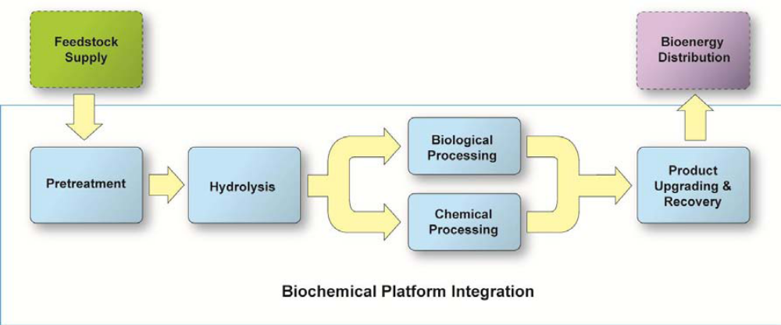
Figure 2.11 Biochemical Conversion Route for Biomass to Biofuels

Conditioning: In some process configurations, the pretreated material goes through a hydrolysate conditioning and/or neutralization process which removes undesirable byproducts from the pretreatment process that are toxic to the fermenting organism and adjusts the pH of the reactant.

Hydrolysis/Saccharification: In the hydrolysis step, the pretreated material with the remaining solid carbohydrate fraction, primarily cellulose, is saccharified, releasing glucose. This can be done with enzymes such as cellulases. Addition of other enzymes such as xylanases in this step may allow for less severe pretreatment, resulting in a reduced overall pretreatment and hydrolysis cost. Depending on the process design, enzymatic hydrolysis requires from several hours to several days, after which the mixture of sugars and any unreacted cellulose is transferred to the fermenter. Currently, the process concept under development assumes that the cellulase enzymes are purchased from enzyme companies, like other consumable catalysts and chemicals. The current concept may also combine the hydrolysis and fermentation steps.

Biological Processing: Currently a fermentation step, an inoculum of a fermenting organism is added and fermentation of all sugars to ethanol is carried out while continuing to utilize the enzymes for further glucose production from any remaining solid cellulose. After a few days of fermentation and continued saccharification, nearly all of the sugars are converted to ethanol. The resulting mixture is sent to product recovery. Other routes, both fermentative and non-fermentative, to ethanol and other biofuels and bioproducts are being explored as well.

Chemical or Catalytic Processing: Chemical or catalytic conversion can be used in place of or in addition to fermentation to convert the hydrolysis products, be they sugars, alcohols or a variety of other stable oxygenates to the desired fuel. The addition of a catalyst works to make a reaction less energy intensive, thus making the entire process more efficient. However, different reactions achieve different yields and intermediates while targeting different end fuels, so the research is aimed at identifying optimum combinations with respect to process efficiency, feedstock utilization, cost, sustainability, and finished product characteristics. Additionally, chemical processing could produce bioproducts, however, this is not a current Program focus.

Product Upgrading and Recovery: Product upgrading and recovery varies based on the type of conversion used and the type of product generated, but in general, involves any necessary hydrogenation of alkenes, distillation, and some cleanup processes to separate the fuel from the water and residual solids. Residual solids are composed primarily of lignin which can be burned for combined heat and power generation, chemically converted to intermediate chemicals, or also converted to synthesis gas or pyrolysis oil intermediates for other uses.
Topic Areas:
The limitations of the FOA apply to all Topic Areas. To reiterate, this FOA is restricted to the improvement and development of pretreatment, hydrolysis, and conversion technologies leading to production of alcohols and other petroleum replacement products. Conversion technologies for the production of ethanol are expressly excluded.
Topic Area 1:
This FOA is seeking applications under Topic Area 1 that address process improvements to a single unit operation within an integrated biofuels production system. The applications under this topic area are not required to demonstrate the process in an integrated fashion; however, the applicant is limited to one and only one process operation in which to demonstrate process improvements. The scale of the process is intended to be between bench scale (1L) and engineering scale (up to 500L or ~132 gallons). Proposals for units greater than 500L will be excluded from the FOA. Please note that any proposed process improvements utilizing heterotropic algal conversion systems are excluded from this Topic Area and may apply only to Topic Area 3.
Topic Area 2:
This FOA is seeking applications under Topic Area 2 that address process improvements to 2 or more unit operations within an integrated system. The applications under this topic area will be required to demonstrate the process improvements in an integrated fashion. While it is not required that the proposed process improvements occur sequentially within the process, it is required that all necessary process steps be available to demonstrate an integrated process. The scale of the processes is intended to be between bench scale (1L) and engineering scale (up to 500L or ~132 gallons). Proposals for units greater than 500L will be excluded from the FOA. Please note that any proposed process improvements utilizing heterotropic algal conversion systems are excluded from this Topic Area and may apply only to Topic Area 3.
Topic Area 3:
This FOA is seeking applications under Topic Area 3 that address process improvements to 1 or more unit operations within an integrated algal biofuels production system, in which the process improvements utilize heterotropic algal based organisms as the primary conversion technology. The applications under this topic area are not required to demonstrate the process in an integrated fashion if only one unit operation is being addressed under the application. While it is not required that the proposed process improvements occur sequentially within the process, if an application is addressing multiple unit operations, it is required that all necessary process steps be available to demonstrate an integrated process. The scale of the process is intended to be between bench scale (1L) and engineering scale (up to 500L or ~132 gallons). Proposals for units greater than 500L will be excluded from the FOA.

Merit Review Criteria Explanations
While each application should address the Merit Review Criteria as provided in Section V.A.2 of this FOA, the following items provide additional details related to those criteria. Each Topic Area will utilize the same criteria.
Technical Merit & Feasibility Requirements – Criterion 1
- Tables (Table A1-A4) are provided in Appendix F for the applicant to provide current performance data and intermediate and commercial targets for the processes relevant to the application. Applicants MUST complete the appropriate tables with the best current data, as well as realistic and relevant technical targets, and provide a discussion addressing the controls and quality assurance strategies utilized. Applications submitted without the appropriate technical tables will be excluded from review under this FOA.
- Process Operations rationale: Please include simple process flow diagrams (pfd), general mass and energy balances associated with these pfds. Please provide the comparative advantage to using the proposed process over other common processes via economic, operational or engineering justifications.
Commercialization/Business Plans and Economic Analysis – Criterion 2
- Table B is provided in Appendix F for the applicant to provide current cost estimates for the overall process. Applicants MUST complete the table with their best current data and cost estimates, as well as the targeted costs that will result from achieving the proposed technical improvements (targets), and provide a discussion addressing the controls and quality assurance strategies utilized. Applications submitted without the appropriate economic tables will be excluded from review under this FOA.
- If improvements to the production of a non-fuel product is proposed the application must provide a detailed analysis of the costs benefits of the process when utilized within an integrated biorefinery (IBR) setting. The primary product of the IBR must be a fuel and the proposed product cannot utilize more than 50% of the sugar or biomass stream. Additionally, for all targeted fuel intermediates there must have a known path to a hydrocarbon fuel or fuel precursor.
- Provide an accurate and incisive market analysis in relation to target system parameters.
- Estimate the competitive position of the systems in the market(s) being addressed.
- The extent of competition in this market segment should be described and the applicant’s relative position in competing in that market, including all competitive advantages that can be provided.
- Address the technical and financial viability of the manufacturing scale-up plan, including plans for management of key environmental safety & health (ES&H) issues.
Business Plan
- Provide a clear and logical team structure and the plan for team operations to carry out the business and commercialization plan.
- Address the extent to which the proposed R&D plan and stage-gate management approach demonstrate a viable trajectory to a business model that will achieve the performance metrics. Applicants must identify quantifiable, economic milestones that will be met at various stages.
- Discuss quality assurance plans and procedures utilized.
- The applicant’s plan is requested to describe how the team’s cooperating membership will produce, qualify performance, market, and deploy operations within biofuel production processes in the commercial market place. The business plan will be reevaluated at the Stage-Gate review at the end of the first budget period (approximately 24 months after award) at which time progress towards intermediate target goal attainment will be assessed.
Implementation/Project Management Plan – Criterion 3
- Decision points: This plan must identify decision points and go/no-go decision criteria including
  - A go/no go decision point at approximately 22-23 months after formal initiation of the project that will be assessed in a Stage-Gate review conducted by DOE. Based on the results of the Stage-Gate review, DOE will make the go/no go decision. If the project is selected to continue, funding for the remaining project will be provided, subject to availability of the funds. (Appendix G contains stage-gate type criteria that will be used)
- Genetically Modified Organisms (GMOs): If a genetically modified feedstock will be used, describe how regulatory issues will be addressed and what impact using the GMOs will have on the ability of the project to produce biofuels at the application’s forecasted production volume and cost.
- Feedstock supply: It is expected that the applicant will be employing a compositionally consistent feedstock either from their own handling process that produces the feedstock reproducibly, or from a partner that supplies a consistent feedstock in sufficient quantities to provide supplies throughout the life of the project. Sufficient quality controls to ensure consistency of feedstock supply and process operations will need to be demonstrated to satisfy the merit review that feedstock variability is not confounding the process testing results and that process testing can be carried out in a reproducible manner.

Qualifications and Resources - Criteria 4
- Personnel: Resumes or biographical sketches of key individuals in the project should show a reasonable link to how their expertise will be applied to the project. A key element in the evaluation will be whether an applicant’s team exhibits the necessary skills or whether such skill sets will need to be developed or procured during the project. Use of outside consultants to augment personnel needs will not count negatively in the merit review scoring.
- Organizational structure:. A RASCI chart (responsible, accountable, support, consult and inform) or equivalent work breakdown structure chart would be advantageous to include in the application. Also include a narrative describing the extent to which each team member with responsibility for tasks is linked to meeting the goals and objectives described in the project management plan (PMP).
- Resource assurances: The adequacy of the infrastructure and resources proposed to support achievement of the project objectives, including those of subcontractors and/or other partners. Are the resources needed for the team to perform their work already in place or will unique or novel systems be required to be developed such as new pretreatment systems, new enzymatic hydrolysis systems or sugar conversion bio/catalysts, etc.?
- Need for facilities: The reasonableness of any request for proposed new facilities and the perceived value-added to the achievement of the objectives in this FOA.
- Ownership of technology: Provide levels of ownership. Will the applicant require licensing of technology to conduct the work or is the information in the public domain allowing anyone access to the technology? Does the project team possess all the intellectual property they need to carry out the work or will partnering with others be required to achieve project goals and objectives? The statement outlined in Appendix H must be provided.

Appendix F– Data Tables

The tables provided below MUST utilized to demonstrate performance target metrics as well as the estimated production cost impacts of the proposed project. Applications submitted without the appropriate technical and economic tables will be excluded from review under this FOA. Complete these tables as they apply to the proposed project. It is expected that all relevant data will be provided where possible. The tables are available in Excel format as an attachment to the FOA.

Benchmark and Target Performance metric Tables:

Table A1 – Feedstock, Pretreatment and Hydrolysis/Saccharification Technology Performance Summary
Table A1.a – Enzyme Performance & Cost Contribution
Table A2 – Fermentation Technologies for Advanced Biofuels
Table A3 – Combined Bioprocessing Technologies for Advanced Biofuels
Table A4 – Sugar Chemical Synthesis Technology Performance Summary
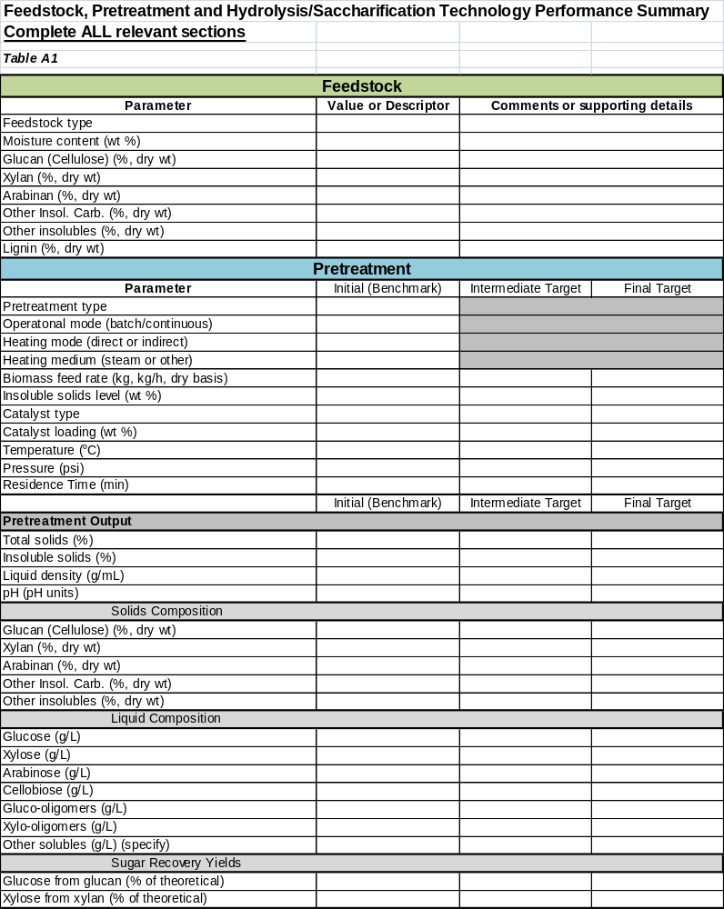

Table A1 continued
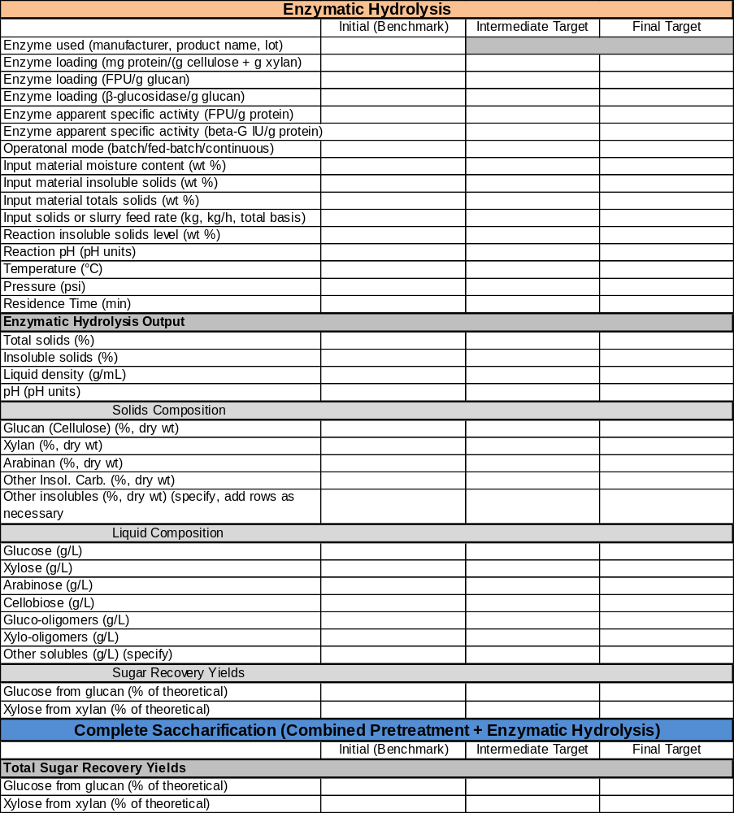
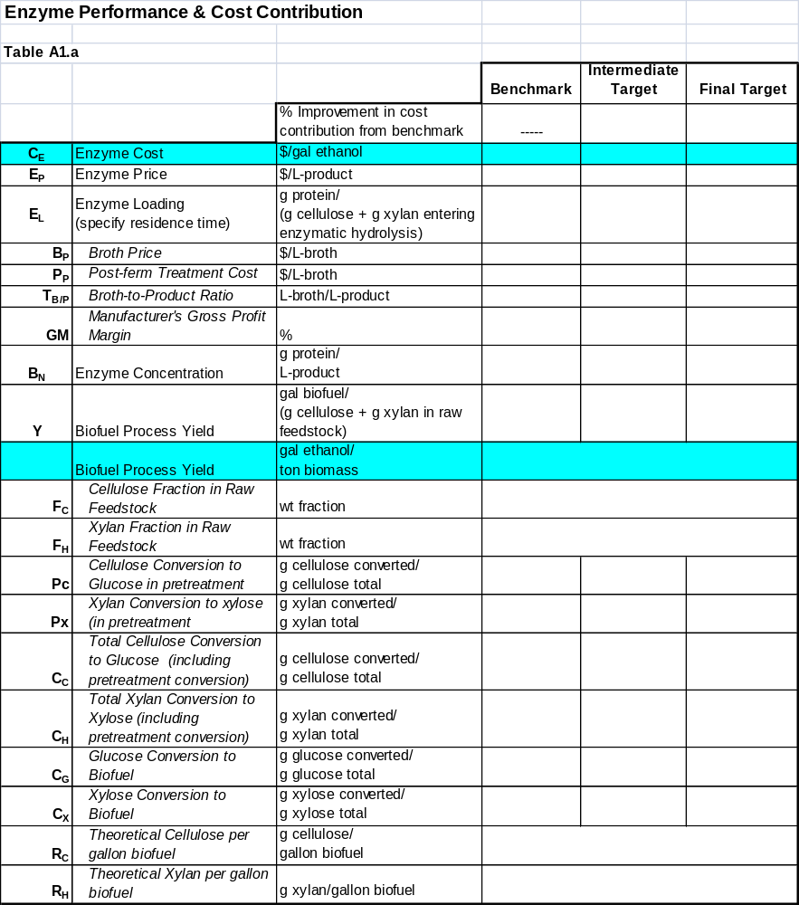

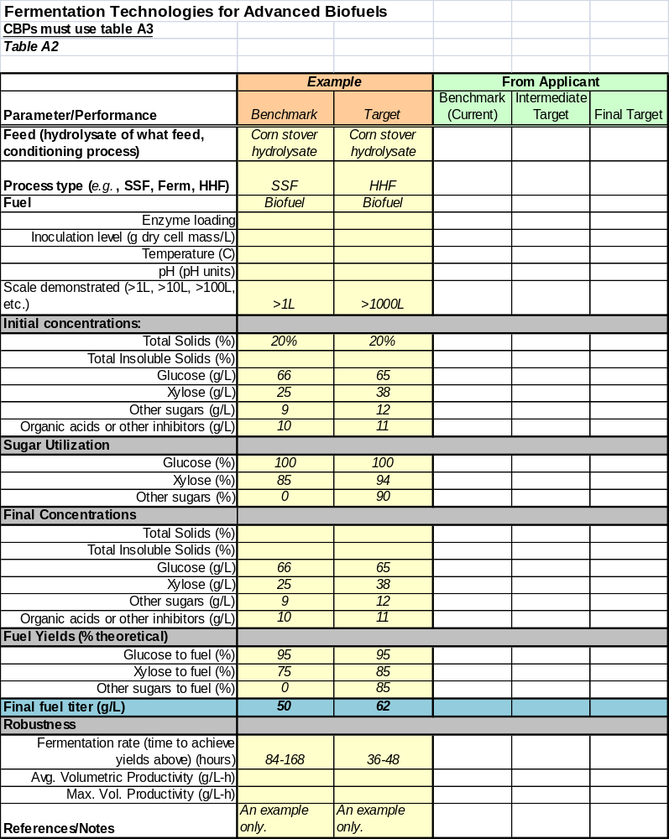
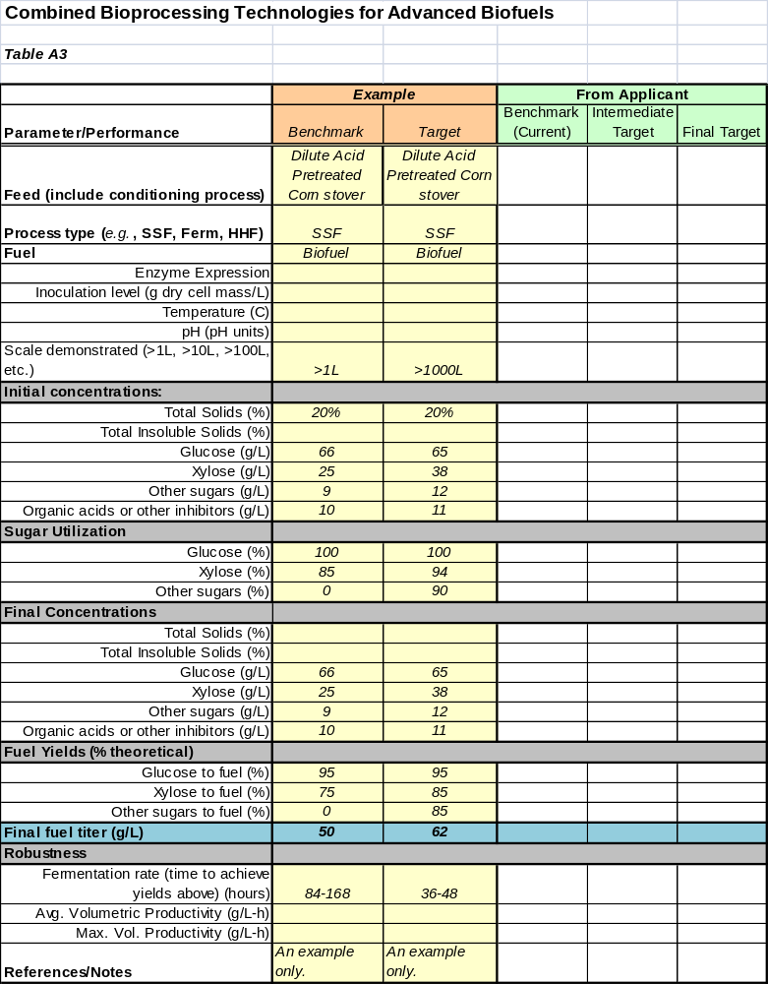
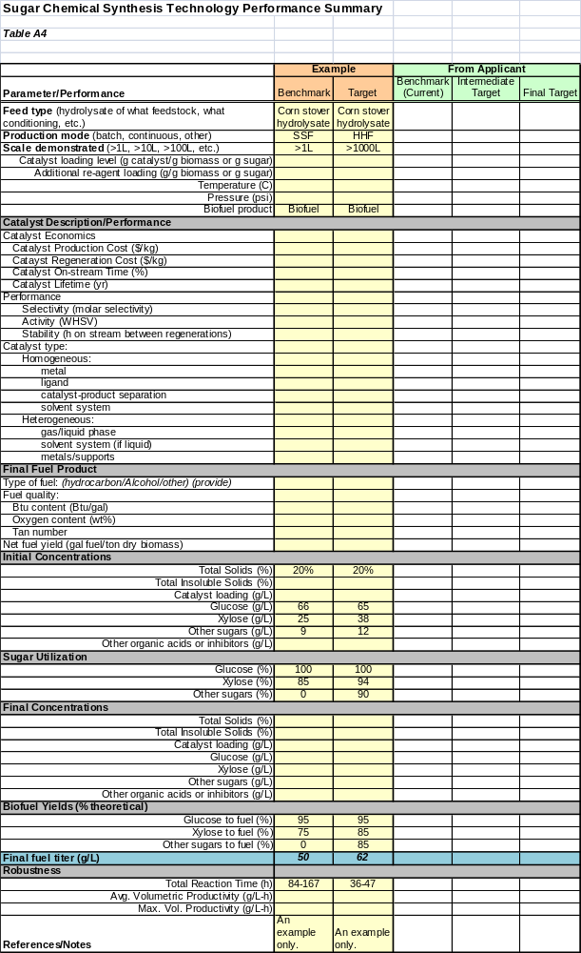
Technical & Economics Metric Table B - Process Details and Cost Estimate

Table B, “Process Details and Cost Estimate,” MUST be completed in as much detail as possible to demonstrate the technical and economic viability of the enzyme system and this work’s impact on reducing ethanol production costs. Use a 2007$ cost year or state the cost year used and why if different. The “Benchmark” column should be filled out with best available performance data and costs. The “Intermediate Target” and “Final Target” columns should be process data and cost targets for the proposed work. For those costs unavailable or outside of the proposed work, please utilize the fixed costs provided, as appropriate to the proposal.
Table B:
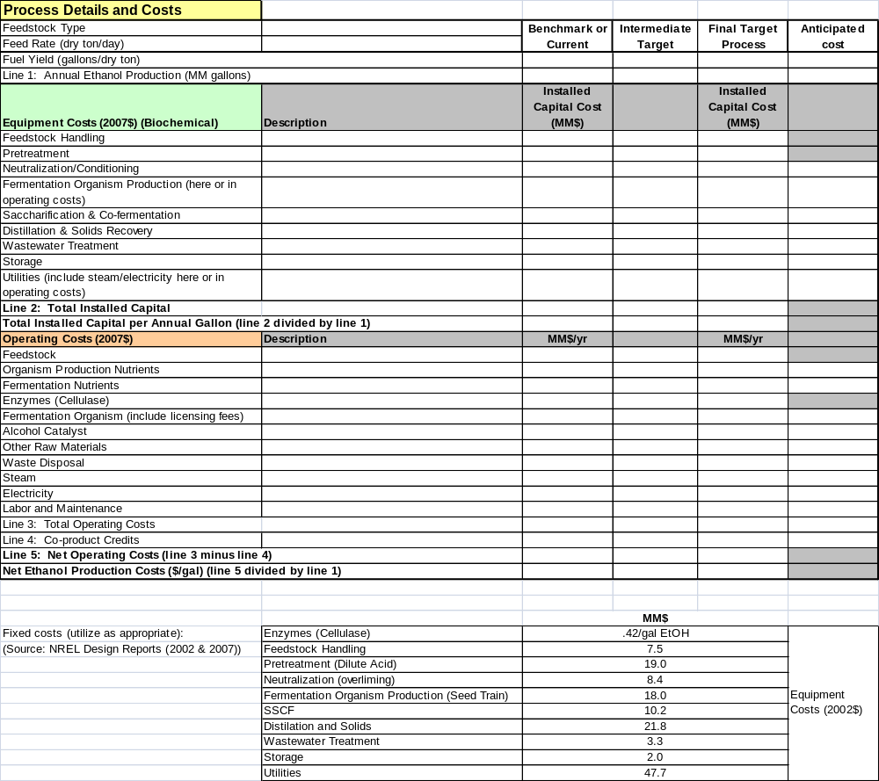

Appendix G – Stage-Gate Review Guidelines

Stage gating is a system of project management originally proposed by Cooper as a model for product development projects to reduce costs and time to market, and has been adapted and extended by R&D organizations in the process industries for process technology development. The goal is to; “Bring science and technology to commercial application sooner, at lower cost, and with improved probability of success.”

This is to be accomplished through:
- Strong Customer/Competition orientation
- Better homework up-front
- Quality of execution
- Sharper focus, better prioritization
- Fast-paced, parallel processing
- Multifunctional team approach

Stage Gate Process

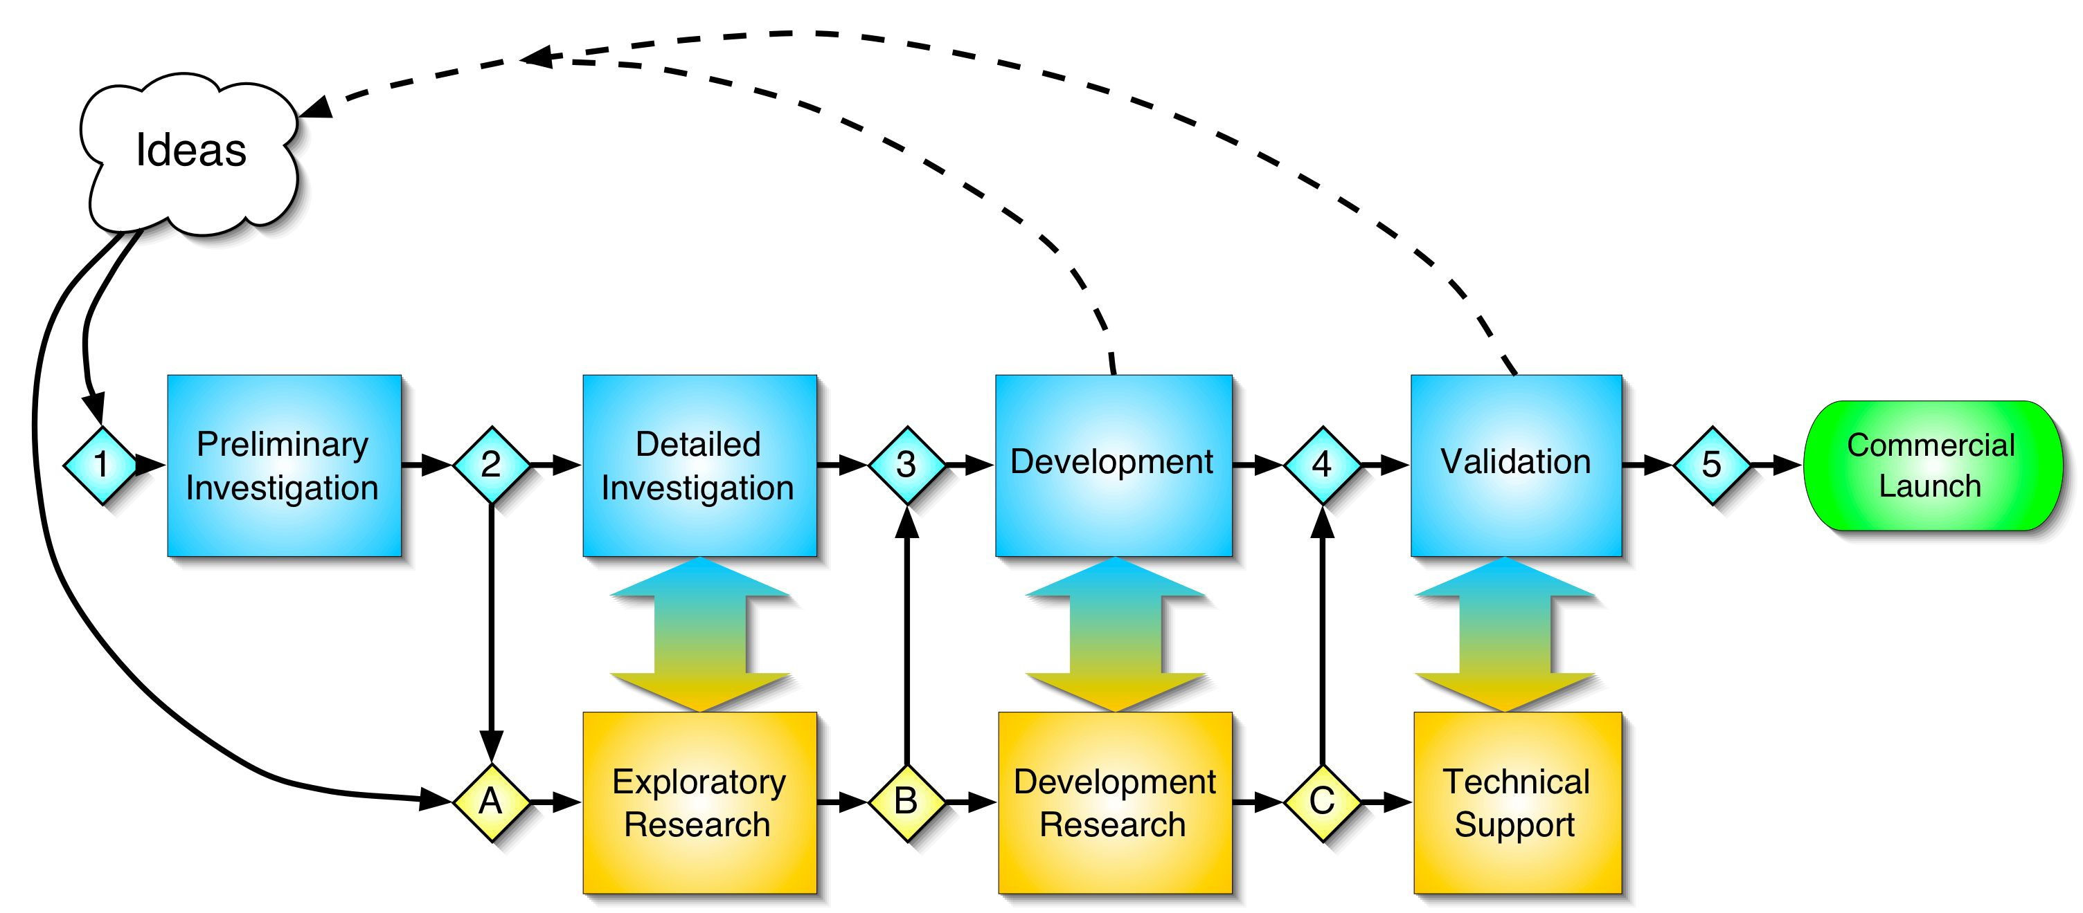

- First Decision – Have criteria been met?
  - Yes – Pass to next Stage
    - Second Decision – What is the Priority?
      - High – Go
      - Low - Hold
  - No – Terminate or Recycle

Idea Generation and Evaluation
New ideas are critical to successful technology development. In our implementation of the stage gate process, we envision a number of specific ways in which new ideas can be brought into the program. The first is through regular broad based, competitive solicitations to industry and academia aimed explicitly at providing initial funding of new concepts. The Program Manager may also elect to fund a seed project for investigating a new technological tool or approach that may offer as yet unspecified applications in bioconversion, and about which we may want to learn more. Examples of this include the general area of biocatalysis or new tools for genetic manipulation. Such a seed project could lead to competitive solicitations or generate ideas directly for consideration in the stage gate process. Finally, individual researchers may submit new ideas for research or development for consideration. An idea submission form is available to suggest ideas. All ideas are subjected to a Gate 1 review, the outcome of which is a decision to place the project in the commercial track, the research track, or to do nothing with the project idea.

- Gate 1: The Gate 1 reviewers include the OBP Program Manager, OBP Technology Manager, and appropriate additional HQ and Project Management Center (PMC) staff members.

- Stage 1: Preliminary Investigation. This is a purposefully “inexpensive” step that involves a preliminary technical and market assessment of the project idea based on literature, internal knowledge, and customer contacts. Economic projections are "back of the envelope" and no laboratory work is included. The stage is intended to make a nominal amount of funding available for development of an idea to the point where a decision can be made on whether or not to include the project in the portfolio and fund the next stage. If the project idea looks favorable then a project plan, or proposal, is developed and presented at either a Gate A or a Gate 2 review, depending on the type of project idea. All applications must be beyond this stage.

The Commercial Track
Any project (idea) suggested for the commercial track must be able to clearly envision how and where the technology would be commercialized from the outset. However, since DOE will not commercialize technology, industrial involvement increases dramatically as the project moves forward. Starting after Stage 1, the commercial development pathway includes four more gates and stages:

- Gate 2: Gate keepers include OBP management, PMC management, and outside experts. The review criteria focus on market and customers, economic feasibility, technology feasibility, legal aspects, environmental issues, and others.

- Stage 2: Detailed Investigation. This is the critical homework stage where investigation and planning are the emphasis. Work must show the unique capabilities of the technology and demonstrate unproven steps in a laboratory setting. In Figure 1, the recycle arrow between Stage 2 and Stage A implies the kind of interaction that may be required when experiments to prove feasibility raise new and important scientific questions. A business plan should be developed that fully illustrates the market and route to commercialization. This will require assessments of customers, competitive technology, technical details, and financial evaluation based on process modeling. The technical assessment requires identification of routes and solutions to problems as well as what risks will be involved.

- Gate 3: This Gate review must confirm that the project homework in Stage 2 has been adequately done. Gate 3 keepers will include external parties, industry expert reviewers along with DOE.

- Stage 3: Development. If the project gets this far, it is ready for significant spending on the technical development of the process or product. Stage 3 is comprised of projects wherein industry cost share would be at least 30% or higher. Stage 3 needs to convert Stage 2’s business plan to concrete deliverables and demonstrate or develop convincing data that the issues identified in the earlier stages can be or are resolved. Integrated, crosscutting technical work is the emphasis including prototype demonstration of unit operations, demonstration of simulated integration at real processing conditions, and development of engineering scale-up data. From the outset, a Stage 3 project must have a detailed plan with milestones and checkpoints for progress. For multiyear projects there will be thorough annual reviews to insure that the project is progressing per the original plan. If problems are identified a new plan will likely be required and potentially even a new Gate review. At the end of this stage the technology should be developed to the point where industry is ready to assume leadership, control of the project and federal cost sharing drops below 50%.

- Gate 4: This gate review will be lead by the lead industrial partners and will meet their requirements. Industry accepts that sufficient laboratory and prototype work has been completed to establish a project that they will carry forth to Stage 4 (Validation) and Stage 5 (Commercialization). DOE will not participate in the technology development effort past Gate 4 into Stage 4 without a partner who is willing and has the ability to commercialize the technology.

- Stage 4: Testing and Validation. Spending at this point takes a much bigger step as demonstration scale testing of the product/process begins. The information created in this stage must be sufficient to support a decision for making the investment in commercial scale production. Once a project has reached this stage, DOE expects that an industrial partner is leading the work and largely financing the project. The Energy Policy Act (EPAct) requires 50% non-Federal government cost share for demonstration projects but does not prevent even lower federal cost-share commitments.

- Gate 5: The decision to commercialize a technology belongs with the industrial partner.

- Stage 5: Full Production and Market Launch. This level of effort is, clearly, almost exclusively the domain of an industrial company The Program can provide some limited technical support, but the lion’s share of the effort and financing is expected to come from the private sector.

Stage Descriptions and Gate Review Criteria

Stage 2: Detailed Investigation
Goals:
- Critically investigate all aspects of background.
- Demonstrate process feasibility.
- Develop a business plan.

Stage 2 Work Activities:

Investigation and planning is the emphasis. Stage 2 must show the unique capabilities of the process and demonstrate unproven steps in a laboratory setting. The business plan should fully illustrate the market and route to commercialization.

- Market Assessment
- Detailed customer assessment of wants and needs (product specifications), requires direct interaction with potential customers.
- Probably requires participation of outside marketing firms specializing in the specific area.

Research Activities
- Demonstrate unique, cost critical and untried process steps in minimum scale laboratory setting.
- Produce only enough material to prove necessary properties of product.
- Develop Competitive Technology Assessment
- Review patent literature.
- Compare this process to other known processes and products.
- Detailed Technical Assessment
    - Investigate alternative technical solutions and routes.
    - Investigate and document technical risks.
    - Review patent literature.
    - Review legal, regulatory and safety issues applicable to this process. Address potential impacts of any of these issues on the proposed process.
- Financial Assessment
    - Develop plausible process route for commercialization and evaluate economics.
    - Use results of critical experiments to help substantiate cost critical operations.
    - Use cost sensitivities to illustrate the criticality of various process steps and estimate risk of various assumptions and unproven steps. This will aid in risk assessment of the business plan.

Stage 2 Outputs:

- Market Assessment
- Clear understanding of customer needs and wants (specifications). Market size and barriers to entry should be assessed.
- Research Results
- Detailed documentation of all relevant experimental work.
- Added confidence (or feasibility) in unique process steps.
- Possible sample quantities of key products for preliminary evaluations.
- Competitive Technology/Detailed Technical Assessment
- Clearly documented description of all competitive technologies and what is advantageous to this process/product.
- Assessment of other routes to this technology and why this one should be pursued.
- Address any identified legal, regulatory, environmental or safety concerns that this process will possibly face.
- Financial Assessment
- Conceptual process design and economics. This should include sensitivity study of key process steps and variables.
- Business plan for Stages 3 through 5. This plan should address the technical risks identified and the legal, regulatory, environmental and safety concerns.

Stage 3: Development
Goals:
- Demonstrate or develop convincing data that issues identified in Stage 2 can be resolved.
- Convert Business Plan from (Stage 2) into Concrete Deliverables that can be evaluated.

Stage 3 Work Activities:

Technical work is the emphasis. Stage 3 is proportionately cost-shared by DOE with industry and led by industry partner(s) who provide significant cost share (up to 50%).
- Market Assessment
- Check market and potential customers to determine continued need, or if end product or time to market changes.

Research Activities

Prototype demonstration of process unit operations

Equipment should be large enough and similar enough to envisioned commercial equipment that risk in scaling to demonstration scale (Stage 4) is minimized or at least well understood.

Demonstration of simulated integration at real processing conditions

Consideration of pseudo-steady state operation with appropriate recycle, accumulation, contamination, losses, waste steams, etc. and their impact on subsequent scale-up.
- Development of Engineering Scale-up Data
  - Consideration should be given to kinetic and physical property data that will be needed to scale-up to demonstration sized equipment.
- Detailed Technical Assessment
    - More detailed process design with partner providing leadership (potentially involving outside consultants).
    - Continue to compare to other known processes.
- Financial Assessment
    - Economic evaluation and business plan refinement (from Stage 2) with partner providing leadership as appropriate (potentially involving outside consultants).

Stage 3 Outputs:

- Market Assessment
    - Updated customer assessment of needs and wants.
  - Research Results
    - Detailed documentation of all relevant experimental work.
    - Mathematical models of key operations, cause and effect relationships including reaction kinetics, particularly for hydrolysis and fermentation.
    - Scale up information from lab or bench scale to prototype, with understanding of subsequent scale-up steps and needs through demonstration (Stage 4) and commercialization (Stage 5).

  - Detailed Technical Assessment
    - Initial process selection (including process flow sheet with material and energy balances, equipment lists, utility balances, process control philosophy, etc.)
    - Updated knowledge gaps with plan of action.
    - List of potential commercial design options and demonstration plans appropriate for each serious design.
    - Recommendation for suitable demonstration facility. This should include the size of the next facility, requirements for data to be collected (completely or partially integrated) and expectations for what is to be determined (e.g., gain experience in the operation of a larger scale unit operation and obtain intermediate scale-up information, test complete integration on accumulation of impurities, produce large quantities of product or by-product for customer or outside vendor testing, etc.)
  - Financial Assessment
    - Economic models constructed for both experimentally verified case and most likely commercial case (the most likely commercial case may rely on additional knowledge to be developed in Stage 4).
    - Business plans for Stages 4 and 5.

Stage 4: Validation

Goals:
- Scale-up the process identified in Stage 3 sufficiently to support the design and construction of a commercial unit.
- Develop convincing process design data to enable process equipment guarantees.
- Produce sufficient quantities of products to satisfy customer evaluations.

Stage 4 Work Activities:

Scale-up work is the emphasis. Stage 4 requires an industrial partner leading and funding the effort. National laboratories would only serve as technical consultants to the partner in the kinds of activities described below.
  - Market Assessment
- Identify specific customers and work with them to develop and test the process or products with their feedstock or process. If dealing with a product rather than a process, produce sufficient quantities to establish the product quality over the range of feedstock envisioned.
- Reevaluate the market and potential customers to determine that a need for the product exists, or if a need exists to change the end product produced or if time to market plans have changed.

Research Activities
- Research activities are typically in support of technology improvements that lead to a more cost-effective or economic process but do not require substantial R&D development time scales.

Market development demonstration of process

Equipment should be large enough and similar enough to envisioned commercial equipment that risk in scaling to commercial scale (Stage 5) is eliminated.

Demonstration of integration at real processing conditions

Process should be integrated as much as possible to identify any problems arising from feedstock quality and recycle (accumulation, contamination, and losses). Waste steams should be closely monitored and proper designs made for their remediation.
- Development of Equipment Guarantees
  - By testing in the demonstration unit or off-site at vendor locations sufficient data should be developed under process conditions (temperature, pressure, actual process streams) to support vendor guarantees for critical pieces of equipment.
- Development of Engineering Scale-up Data
  - Any data found missing from the scale-up to this demonstration should be developed, either at the demonstration scale or back in a laboratory.
  - Detailed Technical Assessment
- Final commercial scale process flow diagrams and equipment specifications should be developed from demonstration scale data or other appropriate information.
- Continue to compare to other known processes.
- Financial Assessment
- Economic evaluation and business plan refinement (from Stage 3) with partner providing leadership.

A Stage Gate Review is to be incorporated into the Project Management Plan (PMP), within 18 – 24 months from the start of the project. The Stage Gate Review will be used to analyse project progress, as it relates to the initial performance data produced before the award, and provided within the application. The data used in the analysis will be provided from the recipient, as well as the validation gathered by NREL after initiation of award. NREL will provide the Stage Gate Review Committee with the results of the technical and commercial validations of the projects, to be performed at the project facilities in the months leading up to the Stage Gate.

The Stage Gate Criterion will include:
  - Business/Marketing Plan development.
  - Plans for moving forward.
  - Progress towards previously determined milestones and targets.
    - Milestones and targets are to be specified within the Project Management Plan.
    - Project specific criteria will be laid out during the negotiation of the award.
The results of the Stage Gate will provide DOE with recommendations as to how to continue with the projects, including scope revisions, continued or additional funding, and termination.

Appendix H – Applicant’s Representation of Its Right to Commercialize Materials and Methods

Please describe your rights to use and commercialize the materials and methods you propose to use as described in your project narrative:

- Do you own all the intellectual property necessary to accomplish your tasks? If not, have you secured all the necessary license rights?

- If the intellectual property is licensed from another party, please describe the terms and conditions of the license(s), including license duration and exclusivity. Please do not submit copies of licenses.

- In lieu of the description required above, you may submit a freedom to operate opinion prepared by your intellectual property counsel.

Please note that you will be required to re-certify your intellectual property rights at each Stage Gate Review. Failure to adequately demonstrate your ownership of these intellectual property rights may result in termination of funding. This document will be attached as explained in the Summary of Required Forms in Part IV.C as an additional attachment.

Appendix I – Project Narrative Cover Sheet Template
This document is also provided as an attachment to this FOA.
Project Narrative Cover Sheet
Integrated Process Improvements for Biochemical Conversion of Biomass Sugars: from Pretreatment to Substitutes for Petroleum-based Feedstocks, Products and Fuels
Funding Opportunity Announcement Number: DE-FOA-0000337
CFDA Number: 81.087 Renewable Energy Research and Development

Applicant Information
Applicant Name:
Project Title:
Major Project Subcontractors:
Key Individuals:

Topic Area (Select ONLY one)
Each applicant is allowed to submit only one application to this FOA. Applicants that submit to none or more than one topic area will be excluded from further review. Select one and only one topic area below.
 | Topic Area 1 |  |  |  |  |  | Topic Area 2 |  |  |  |  | Topic Area 3
Process Improvements to 1 Unit Operation |  |  |  |  | Process Improvements to 2 or more Unit Operations |  |  |  |  |  | Process Improvements to Algal Conversion systems

Project Funding
$  Federal Cost Share Requested ($, from SF-424a, box 5(f)) |  |  |  |  |  | 20%  Minimum required cost share (%). |  |  |  | %  Applicant’s cost share (%)
$  Minimum required cost share ($) (See FOA, Appendix C for the calculation method) |  |  |  |  |  | $  Applicant cost share ($, from SF-424a, box 5(f)) |  |  |  | $  Total Allowable Cost (Total Project Cost, from SF-424a, box 5(g))

Technical Description
Feedstock(s): (if applicable)
Primary Biofuel/Product:
Number of Unit Operations Proposed for Improvement:
Unit Operations to be Improved (e.g. Pretreatment & Fermentation):
Conversion Technology: |  |  |  |  |  | Biochemical |  |  |  | Hybrid (Describe)______________________________________________________
 |  |  |  |  |  | Algae
Provide a Description of the Fuel Market Targeted:
Short Description of Proposed Improvements:
This form is required. It must be completely filled in and be included as the cover page for the “Project Narrative” (FOA, Subpart IV.C. b.). This form may contain confidential /business proprietary information IF it properly marked, but it must not contain any Personally Identifiable Information (PII). This form will count toward the page limit stated in the FOA, Subpart IV.C.b. Non-compliant applications will not be reviewed and will not be eligible for selection.
Failure to submit will result in the application being deemed non-compliant and the application will not be forwarded to the Merit Review Committee.

“Lignocellulosic Biomass to Ethanol Process Design and Economics Utilizing Co-Current Dilute Acid Prehydrolysis and Enzymatic Hydrolysis for Corn Stover,” NREL TP-510-32438, June 2002. http://www.nrel.gov/docs/fy02osti/32438.pdf

